I have gathered ten essential scenario-based microservices questions that individuals typically encounter while designing or debugging their microservice architecture. Although these questions may not cover every possible scenario, they provide significant insights into common issues faced during microservices development.
What measures can be taken to guarantee the scalability and resilience of Microservices?
To ensure that microservices are scalable and resilient, consider the following best practices:
- Design for scalability: Build microservices with scalability in mind from the beginning. Use a modular architecture that allows services to be broken down into smaller components that can be scaled independently.
- Use containerization and orchestration: Use containerization technologies like Docker to package and deploy microservices. Use orchestration tools like Kubernetes to manage and scale containerized services.
- Implement fault tolerance: Design your microservices to handle errors and failures gracefully. Implement retry mechanisms, timeouts, and circuit breakers to ensure that services continue to function even when other services fail.
- Use monitoring and logging: Implement monitoring and logging tools to track the health and performance of microservices. Use this data to identify bottlenecks and optimize performance.
- Use load balancing: Implement load balancing to distribute traffic evenly across multiple instances of a service. Use auto-scaling to automatically adjust the number of instances based on traffic levels.
- Implement caching: Implement caching to reduce the load on backend services and improve response times.
- Use asynchronous messaging: Use asynchronous messaging patterns to decouple services and improve scalability. Implement event-driven architectures using message queues or publish-subscribe systems.
By following these best practices, you can ensure that your microservices are scalable, resilient, and able to handle high volumes of traffic and data without compromising performance or reliability.

What is the recommended approach if two Microservices need to update the same database?
- Use a distributed transaction coordinator : A distributed transaction coordinator can be used to coordinate transactions across multiple services and ensure that updates are performed atomically. A distributed transaction coordinator like Apache Kafka or Apache Zookeeper can ensure that all changes are committed or rolled back together, thus maintaining consistency across services.
- Implement optimistic locking : Optimistic locking is a technique in which a version number is attached to a record in the database. When a service updates the record, it increments the version number. If another service attempts to update the same record concurrently, it checks the version number and rejects the update if the version number has changed. This technique can prevent conflicts and ensure consistency.
- Use event-driven architecture : In an event-driven architecture, microservices communicate with each other by publishing events to a message broker. Other services can then subscribe to these events and respond accordingly. This can help to ensure that updates are performed in a consistent and ordered manner.
- Implement retry and error handling : When multiple services are updating the same database, it is important to implement retry and error handling mechanisms to ensure that failed updates are retried and that errors are handled appropriately. This can help to prevent data inconsistencies and ensure that updates are eventually successful.
By following these best practices, it is possible to ensure that updates to a shared database are performed in a consistent and reliable manner, even when multiple microservices are involved.
What might be causing the delay in startup time for a Microservice with a large database?
There could be several reasons why a microservice is taking a long time to come up due to a large database:
- Database schema : If the database schema is complex and includes many tables, columns, and relationships, it can take a long time for the microservice to initialize and establish a connection to the database.
- Data volume : If the database contains a large volume of data, it can take a long time for the microservice to load and cache the data. This can also slow down database queries and other operations.
- Network latency : If the microservice and the database are located on different servers or in different data centers, network latency can cause delays in establishing a connection and transferring data between the two.
- Hardware limitations : If the hardware used to run the microservice or the database is not powerful enough, it can cause performance issues and slow down startup times.
To address these issues, you could consider:
- Optimizing the database schema by reducing the number of tables, columns, and relationships where possible.
- Implementing pagination or other techniques to limit the amount of data loaded at startup, or using asynchronous loading to load data in the background.
- Moving the microservice and the database to the same server or data center to reduce network latency.
- Upgrading the hardware used to run the microservice and the database to improve performance and reduce startup times.
- Using database connection pooling and other optimization techniques to improve database connection times and query performance.
- Analyzing and optimizing database queries to improve performance and reduce startup times.

If Microservice A communicates with Microservice B, which then communicates with Microservice C, and an exception is thrown by Microservice C, how should the exception be handled?
When Microservice C throws an exception, Microservice B should handle it and return an appropriate response to Microservice A. The exception should be propagated up the call chain from Microservice C to Microservice B, and then to Microservice A.
To handle the exception in Microservice B, you can use a try-catch block or an exception handler. If Microservice C returns an HTTP response with an error code, such as 4xx or 5xx, Microservice B can catch the exception and either rethrow it or wrap it in a new exception with more context information.
For example, if Microservice C returns a 404 Not Found error, Microservice B can catch the exception and wrap it in a new exception with a more descriptive message, such as “Resource not found in Microservice C”. This new exception can then be propagated up to Microservice A along with the appropriate HTTP response code.
It is important to handle exceptions properly in Microservices architecture, as it can impact the overall performance and stability of the system. You should also consider implementing retry mechanisms or fallback strategies in case of exceptions to ensure the system can recover from failures.
Is it necessary for Microservice A to poll Microservice B every time to get the required information, or is there an alternative solution to retrieve only specific parameters?
Instead of polling Microservice B every time to get the information, Microservice A can use a request-response pattern to request only the required parameters from Microservice B. This can be achieved by implementing an API endpoint on Microservice B that returns only the required parameters.
One possible approach is to use a REST API endpoint that accepts the parameters as query parameters or path variables. Microservice A can then make a request to this endpoint to retrieve only the required parameters.
Another approach is to use a message broker or event-driven architecture, where Microservice B publishes events containing the required information, and Microservice A subscribes to these events to retrieve the required parameters. This approach can provide better scalability and performance, as Microservice A doesn’t need to poll Microservice B for information.
In both cases, it is important to ensure proper authentication and authorization mechanisms are in place to ensure that only authorized requests are accepted and processed. Additionally, proper error handling and fault tolerance mechanisms should be implemented to handle failures and ensure system reliability.

If I have a cron job in my application, and it is deployed on multiple instances, will the cron job run simultaneously on all instances?
If your application is deployed on multiple instances, each instance will have its own copy of the cron job. Therefore, if the cron job is scheduled to run at a specific time, each instance will independently execute the cron job at that time.
However, if your cron job relies on shared resources or state, running it concurrently on multiple instances could lead to conflicts and inconsistent results. To avoid this, you can use a distributed locking mechanism to ensure that the cron job is executed by only one instance at a time. Alternatively, you can configure your deployment to run the cron job on a single instance only, such as by using Kubernetes’ job or singleton deployment patterns.
Explain Circuit Breaker pattern, its application in Microservices architecture to handle service failures, and the issues it addresses?
Let’s understand the Circuit Breaker pattern with an an example:
Let’s say we have a microservice that’s responsible for processing payments. Whenever a user wants to make a payment, they send a request to the payment microservice. The payment microservice communicates with the user service to get information about the user making the payment and the account service to retrieve the account information. Once all the information is gathered, the payment microservice processes the payment and sends a response back to the user.
However, one day the user service is experiencing high traffic, and it slows down. As a result, the payment microservice also slows down since it’s waiting for a response from the user service. If the payment microservice doesn’t handle this properly, it could start queuing up requests and eventually run out of resources, leading to a service failure.
This is where the Circuit Breaker pattern comes in. The Circuit Breaker pattern can be used to detect when a service is failing or not responding and take appropriate action. In this example, the Circuit Breaker pattern would be implemented in the payment microservice, and it would monitor the response times of the user service. If the response times exceed a certain threshold, the Circuit Breaker would trip and stop sending requests to the user service. Instead, it would return an error message to the user or try to fulfill the request using a cached response or a fallback service.
Once the user service has recovered and response times have improved, the Circuit Breaker would close and start sending requests to the user service again.
In this way, the Circuit Breaker pattern helps to handle service failures in a Microservices architecture and prevent cascading failures by isolating the failing service and protecting the system from further degradation.

What is Command Query Responsibility Segregation (CQRS) pattern and when is it appropriate to use in Microservices architecture? Explain with an example.
Command Query Responsibility Segregation (CQRS) is a design pattern that separates the operations that read data from those that write data in a microservices architecture. It proposes that commands, which modify data, should be separated from queries, which retrieve data. This separation allows for optimized processing and scalability of each operation, as they have different performance and scaling requirements.
CQRS is appropriate to use when dealing with complex data models or high-performance systems, where the query and write patterns are different, and the system requires a highly responsive and scalable architecture. It also enables the creation of different models for read and write operations, allowing each to evolve independently.
For example, consider a system that manages e-commerce orders. The write operations, such as placing an order or canceling an order, require high consistency and reliability. On the other hand, read operations, such as fetching a customer’s order history or product inventory, are more frequent and require high performance.
With CQRS, the write operations can be handled by a separate service that ensures data consistency and reliability. Meanwhile, read operations can be handled by a separate service that optimizes for high performance, such as caching frequently accessed data or using precomputed views. This separation allows for scalability, performance optimization, and evolution of each service independently.
How can service deployment and rollback be managed in a microservices architecture?
In a microservices architecture, service deployment and rollback require careful planning and execution to ensure smooth and efficient operations. Here are some key considerations:
- Containerization: Containerization is an important step in service deployment and rollback. By using containers, you can package your microservices into a single image, including all dependencies and configurations. This makes it easier to deploy and rollback services.
- Version Control: It is essential to maintain version control of all microservices. This will help in identifying the differences between the current and previous version and will help to rollback the changes if necessary.
- Blue-Green Deployment: This approach involves deploying a new version of the microservice alongside the old version, testing it, and then routing traffic to the new version once it has been verified. If any issues arise, traffic can be easily rerouted back to the previous version.
- Canary Deployment: In this approach, a small percentage of users are routed to the new version of the service, while the rest are still using the old version. This allows for gradual testing and identification of any issues before a full rollout is done.
- Automated Testing: Automated testing is an important part of service deployment and rollback. Unit, integration, and end-to-end tests should be performed to ensure that the microservice is functioning as expected.
- Monitoring and Logging: Monitoring and logging play a critical role in identifying issues with microservices. Logs and metrics should be collected and analyzed in real-time to detect any anomalies or failures.
- Rollback Plan: A rollback plan should be in place in case of any issues with the new version of the microservice. This plan should include steps for rolling back to the previous version, testing it, and identifying the root cause of the issue before attempting another deployment.
By following these best practices, you can ensure smooth service deployment and rollback in a microservices architecture.
What are the advantages of microservices?
Here, are some significant advantages of using Microservices:
- Technology diversity, e., Microservices can mix easily with other frameworks, libraries, and databases
- Fault isolation, e., a process failure should not bring the whole system down.
- Greater support for smaller and parallel team
- Independent deployment
- Deployment time reduce

What are Client certificates?
- Client certificates is a digital certificate used to make authenticated requests to a remote server. It is termed as a client certificate

What is the meaning of Semantic monitoring in Microservices architecture?
- Semantic monitoring combines automated tests with monitoring of the application. It allows you to find out reasons why your business is not getting more profits.

2. Name the key components of Microservices.
- Containers, Clustering, and Orchestration
- IaC [Infrastructure as Code Conception]
- Cloud Infrastructure
- API Gateway
- Enterprise Service Bus
- Service Delivery
3. Explain the challenges found in Microservice deployment.
The deployment of Microservice is a great investment in which many things are to be taken care of. The challenges can be both, technical as well as functional.

The functional challenges are:
- Require heavy investment
- Heavy Infrastructure Setup
- Excessive Planning for managing operations overhead
- Staff Selection and maintenance
The various technical challenges that come to the surface are:
- Communication between different microservices in the application.
- Component automation
- Application maintenance
- Configuration Management
- Heavy Operations Overhead
- Deployment Challenges
- Testing and Debugging Challenges
9. Why do Microservices use containers?
Containers are the easiest and most effective method to manage the microservice-based application. There are several reasons to support this:
- Isolation: Containers provide lightweight, isolated environments for running individual microservices. Each microservice can be packaged as a container image along with its dependencies, libraries, and runtime environment.
- Portability: Microservices packaged as containers can be easily moved and deployed across various infrastructure platforms, such as on-premises servers, public clouds, and hybrid environments.
- Consistency: By packaging microservices as container images, organizations can maintain consistent runtime environments and dependencies across different stages of the software development lifecycle.
- Resource Efficiency: Containers are lightweight and consume fewer resources compared to virtual machines (VMs). This resource efficiency is particularly beneficial in microservices architectures with large numbers of services and instances.
- Scalability: Containers support horizontal scaling, allowing organizations to scale individual microservices independently based on demand.
- Lifecycle Management: Containers provide tools and APIs for managing the lifecycle of microservices, including image creation, deployment, versioning, scaling, and orchestration.
- DevOps Practices: Containers align with DevOps practices and enable organizations to automate the software delivery pipeline from development to production.

18. What are the pros and cons of Microservice Architecture?
Pros of Microservice Architecture:
- Flexibility to use different technologies
- Every microservices work on a single capability
- Guarantees security of each service
- Multiple services are simultaneously developed and deployed
- Supports frequent software releases
Cons of Microservice Architecture:
- Needs more effort from the user end for configuration and other tasks
- Difficult to troubleshoot
- Raises delay because of remote calls
- Difficult to keep up with transaction safety
- Difficult to track data over different boundaries

What are idempotent operations, and why are they important in microservices?
Idempotent operations produce the same result regardless of how many times they are executed, ensuring consistency in distributed systems.

27. How will you monitor microservices deployments and rollbacks effectively?
We can follow the following approach to monitor microservices deployments and rollbacks:
- Version tracking: Keep a record of the deployed versions of each microservice to track changes and rollbacks accurately.
- Real-time monitoring: Utilize monitoring and observability tools to monitor the performance, health, and error rates of the new deployment.
- Canary deployments: Deploy new versions to a subset of users (canary deployments) to assess their behavior and performance before a full rollout.
- A/B testing: Conduct A/B testing during deployments to compare the performance and user experience of different versions.
- Feature flags: Use feature flags to enable or disable specific features, allowing easy rollbacks by simply toggling the feature flag.
- Automated rollbacks: Set up automated rollback mechanisms triggered by predefined health and performance criteria.
- Post-deployment verification: Perform thorough post-deployment testing to ensure that the new version behaves as expected and meets performance requirements.

What is Semantic Monitoring?
41. How to ensure backward compatibility while rolling out new microservices versions?
- API versioning: Use versioning in APIs to introduce changes without affecting existing clients. Maintain the old version for backward compatibility while deploying the new version to accommodate changes.
- Contract testing: Implement contract testing between microservices to ensure that the new version adheres to the contract defined with its dependencies.
- Semantic versioning: Adopt semantic versioning to communicate the nature of changes in a version. Increment the version number based on the extent of changes: major for backward-incompatible changes, minor for backward-compatible additions, and patch for backward-compatible bug fixes.
- Graceful deprecation: If a feature or API is being deprecated, provide sufficient notice and clear communication to consumers to allow for a smooth transition.
- Feature flags: Use feature flags to control the visibility of new features, enabling them for specific users or gradually rolling them out.
- API evolution: When introducing new fields or parameters, design APIs to tolerate the absence of new fields and provide default values when needed.
48. What is the CAP theorem, and how does it relate to microservices?
The CAP theorem defines the challenges faced in distributed systems, focusing on three fundamental attributes
- Consistency: All nodes in the system see the same data at the same time.
- Availability: Every request receives a response, without guarantee that it contains the most recent version of the information.
- Partition Tolerance: The system continues to operate despite network partitions that prevent communication between some nodes.
Q5. How does Microservice Architecture work?
A microservice architecture has the following components:
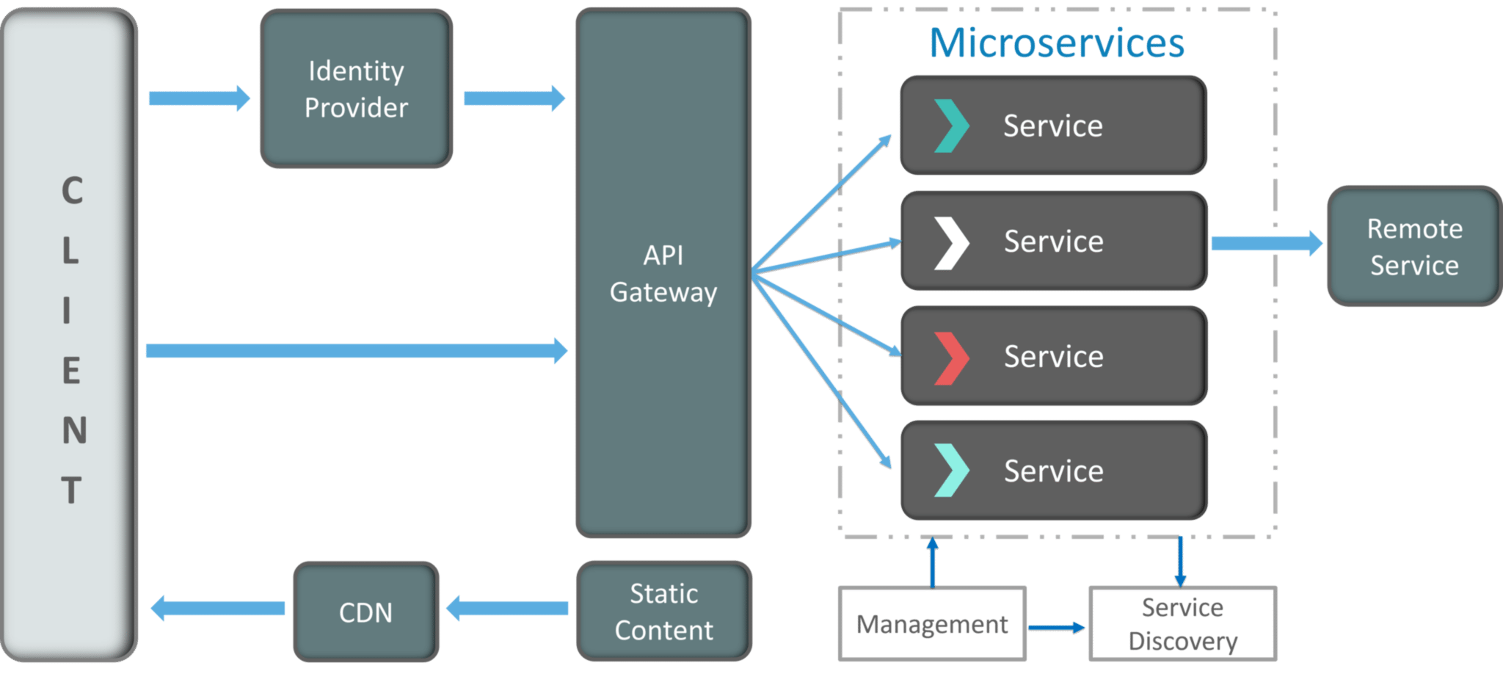
Fig 5: Architecture of Microservices
- Clients – Different users from various devices send requests.
- Identity Providers – Authenticates user or clients identities and issues security tokens.
- API Gateway – Handles client requests.
- Static Content – Houses all the content of the system.
- Management – Balances services on nodes and identifies failures.
- Service Discovery – A guide to find the route of communication between microservices.
- Content Delivery Networks – Distributed network of proxy servers and their data centers.
- Remote Service – Enables the remote access information that resides on a network of IT devices.
- Q6. What are the pros and cons of Microservice Architecture?
Pros of Microservice Architecture | Cons of Microservice Architecture
Freedom to use different technologies | Increases troubleshooting challenges
Each microservices focuses on single capability | Increases delay due to remote calls
Supports individual deployable units | Increased efforts for configuration and other operations
Allow frequent software releases | Difficult to maintain transaction safety
Ensures security of each service | Tough to track data across various boundaries
Mulitple services are parallelly developed and deployed | Difficult to code between services

Q7. What is the difference between Monolithic, SOA and Microservices Architecture?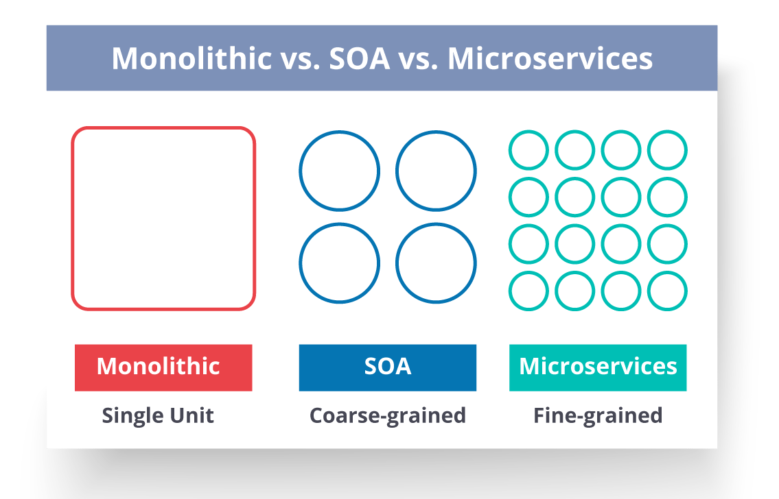
Fig 6: Comparison Between Monolithic SOA & Microservices
- Monolithic Architecture is similar to a big container wherein all the software components of an application are assembled together and tightly packaged.
- A Service-Oriented Architecture is a collection of services which communicate with each other. The communication can involve either simple data passing or it could involve two or more services coordinating some activity.
- Microservice Architecture is an architectural style that structures an application as a collection of small autonomous services, modeled around a business domain.
Q8. What are the challenges you face while working Microservice Architectures?
Developing a number of smaller microservices sounds easy, but the challenges often faced while developing them are as follows.
- Automate the Components: Difficult to automate because there are a number of smaller components. So for each component, we have to follow the stages of Build, Deploy and, Monitor.
- Perceptibility: Maintaining a large number of components together becomes difficult to deploy, maintain, monitor and identify problems. It requires great perceptibility around all the components.
- Configuration Management: Maintaining the configurations for the components across the various environments becomes tough sometimes.
- Debugging: Difficult to find out each and every service for an error. It is essential to maintain centralized logging and dashboards to debug problems.

Q9. What are the key differences between SOA and Microservices Architecture?
- The key differences between SOA and microservices are as follows:
SOA | Microservices
Follows “share-as-much-as-possible” architecture approach | Follows “share-as-little-as-possible” architecture approach
Importance is on business functionality reuse | Importance is on the concept of “bounded context”
They have common governance and standards | They focus on people collaboration and freedom of other options
Uses Enterprise Service bus (ESB) for communication | Simple messaging system
They support multiple message protocols | They use lightweight protocols such as HTTP/REST etc.
Multi-threaded with more overheads to handle I/O | Single-threaded usually with the use of Event Loop features for non-locking I/O handling
Maximizes application service reusability | Focuses on decoupling
Traditional Relational Databases are more often used | Modern Relational Databases are more often used
A systematic change requires modifying the monolith | A systematic change is to create a new service
DevOps / Continuous Delivery is becoming popular, but not yet mainstream | Strong focus on DevOps / Continuous Delivery

Q13. In a Microservices setting, how useful are reports and dashboards?
In a Microservices setting, reports and dashboards are incredibly useful and often vital for the effective operation and management of the distributed system. Here are some reasons why reports and dashboards are essential in a Microservices environment:
- Visibility into Microservices : Microservices design can be made up of many different services, each of which is responsible for a different set of functions. Reports and dashboards give a consolidated view of these services, making it easier for devs, management teams, and users to track and understand the health and performance of the system as a whole.
- Service Monitoring and Debugging : Reports and graphs let you keep an eye on the response times, mistake rates, and resource usage of each microservice in real time. This makes it easier to find speed problems, bottlenecks, and errors in individual services and fix them quickly.
- End-to-End System Performance : Dashboards show how a program works as a whole, including how the microservices work together. This end-to-end view makes it easier to find problems caused by exchanges between services and makes sure that services work well together.
- Scalability and Resource Management :Monitoring how each microservice uses its resources helps with capacity planning and making the best use of resources. Reports and tools help teams find services that need more resources and change them so they can handle more traffic.
- Alerting and Incident Response : Dashboards can be set up to send alerts based on predetermined limits, which makes it possible to respond to incidents in a timely manner. Teams can get alerts in real time, which lets them act right away when important events or service breakdowns happen.
- Versioning and Deployment Analysis : When updates or changes are made to microservices, reports and graphs can help compare how well the different versions of the service work. This lets teams figure out how changes will affect things and make sure deployments go smoothly and work well.
- Business Metrics and Decision Making : Metrics that are important to a business, like user interaction, sales, and conversion rates, can be shown in reports and screens. These insights help stakeholders make choices based on data, understand how microservices affect business performance, and decide which changes to make first.
- Security and Compliance Monitoring : Centralizing security logs and data in reports and dashboards makes it easier to find and deal with possible security risks and make sure that security policies are being followed.
- User Behavior Analysis : Analyzing user interactions with various microservices gives significant information into user behavior and preferences. This knowledge helps improve the user experience and make services fit the wants of the user.
Overall, reports and dashboards are very important in a Microservices setting because they provide clarity, track system success, and make it easier to make good decisions. They make it easier to see what’s going on and let teams react to problems before they happen. This makes microservices-based apps more stable, scalable, and reliable.
Q16. What is REST/RESTful and what are its uses?
Representational State Transfer (REST)/RESTful web services are an architectural style to help computer systems communicate over the internet. This makes microservices easier to understand and implement.
Q25. What is an Idempotence and where it is used?
Idempotence is the property of being able to do something twice in such a way that the end result will remain the same i.e. as if it had been done once only.
Usage: Idempotence is used at the remote service, or data source so that, when it receives the instruction more than once, it only processes the instruction once.
Q29. What are Client certificates?
A type of digital certificate that is used by client systems to make authenticated requests to a remote server is known as the client certificate. Client certificates play a very important role in many mutual authentication designs, providing strong assurances of a requester’s identity.
Q36. What is DRY in Microservices architecture?
DRY stands for Don’t Repeat Yourself. It basically promotes the concept of reusing the code. This results in developing and sharing the libraries which in turn result in tight coupling.
Q37. What is a Consumer-Driven Contract (CDC)?
This is basically a pattern for developing Microservices so that they can be used by external systems. When we work on microservices, there is a particular provider who builds it and there are one or more consumers who use Microservice.
Generally, providers specify the interfaces in an XML document. But in Consumer Driven Contract, each consumer of service conveys the interface expected from the Provider.
Q38. What is the role of Web, RESTful APIs in Microservices?
A microservice architecture is based on a concept wherein all its services should be able to interact with each other to build a business functionality. So, to achieve this, each microservice must have an interface. This makes the web API a very important enabler of microservices. Being based on the open networking principles of the Web, RESTful APIs provide the most logical model for building interfaces between the various components of a microservice architecture.
Q39. What do you understand by Semantic monitoring in Microservices architecture?
Semantic monitoring, also known as synthetic monitoring combines automated tests with monitoring the application in order to detect business failing factors.
Q56. Explain the way to implement service discovery in a microservices architecture.
Implementing service discovery in a Microservices architecture involves setting up a service registry and configuring individual Microservices to register themselves with the registry. Clients can then query the service registry to discover the locations of the services they need to communicate with. Here’s a step-by-step guide to implementing service discovery in a Microservices environment:
- Choose a Service Registry: Select a service registry tool that fits your technology stack and requirements. Some popular service registry options are Eureka (by Netflix), Consul, etc., and ZooKeeper. Each has its strengths and features, so choose the one that best suits your needs.
- Set Up the Service Registry: Install and configure the chosen service registry tool. In a distributed Microservices architecture, it’s good practice to set up multiple instances of the service registry for redundancy and fault tolerance.
- Service Registration: In each Microservice, add code to register with the service registry when it starts up. This registration process typically involves sending essential metadata such as the service name, instance ID, host, port, and health status to the service registry.
- Health Checks: Implement health checks in each Microservice. Periodically, the Microservice sends heartbeats or health check status to the service registry to indicate its availability and health. If a service fails health checks, it is automatically removed from the registry.
- Service Discovery: Clients that need to interact with specific Microservices will query the service registry for the locations of those services. The service registry responds with the available instances of the requested service, along with their metadata.
- Load Balancing (Optional): To achieve better performance and resource utilization, clients can use load balancing strategies when interacting with Microservices. They can distribute incoming requests across available instances of the service retrieved from the service registry.
- Client-Side Discovery and Circuit Breakers: Implement client-side discovery to allow the clients to handle service location and load balancing themselves. Additionally, consider using circuit breakers to prevent cascading failures when interacting with services.
- Resilience and High Availability: For high availability and fault tolerance, deploy multiple instances of the service registry and use a peer-to-peer communication model. This ensures that even if some instances fail, others can continue serving requests.
- Monitoring and Alerting: Implement monitoring and alerting for the service registry and Microservices. Monitor the health of service instances and the registry itself, and set up alerts for any anomalies or failures.
By putting service discovery in place in a Microservices design, you make it possible for services to talk to each other in a dynamic and seamless way. This promotes loose coupling and scaling. Service discovery makes it easier to launch, scale, and handle Microservices. This means that the system can adapt to changes in the service landscape without having to be manually reconfigured or have service endpoints hardcoded.
How can you make sure a microservices-based application can handle more users as the application becomes more popular?
How do you handle data consistency in a microservices application?
What is the difference between Saga and 2PC?
Why do we need to use the API Gateway pattern?

Question: What are the main components of Microservices?
Answer: The main components for a Microservice Architecture are:
- Containers, Clustering, and Orchestration
- IaC [Infrastructure as Code Conception]
- Cloud Infrastructure
- API Gateway
- Enterprise Service Bus
- Service Delivery

Question: What are the main challenges in Microservice Deployment?
Answer: The challenges in Microservice can be both technical as well as functional.
From the point of business, the main challenges are:
- Require heavy investment
- Heavy Infrastructure Setup
- Excessive Planning for managing operations overhead
- Staff Selection and maintenance.
From a technical standpoint –
- Communication between different microservices in the application.
- Component automation
- Application maintenance
- Configuration Management
- Heavy Operations Overhead
- Deployment Challenges
- Testing and Debugging Challenges

Question: What are the advantages and disadvantages of Microservices?
Answer:
Advantages:
- Improved Scalability
- Fault Isolation
- Localized Complexity
- Increased Agility
- Simplified Debugging & Maintenance
- Better correspondence of developers with business users.
- Smaller development teams
- Better scope for technology upgradation.

Disadvantages:
- Complicated as a whole.
- Requires accurate pre-planning
- Modular dependencies are hard to calculate.
- Less control over third party applications
- Modular Interdependencies are challenging to track.
- More opportunities for malicious intrusions.
- Complete end-to-end testing is difficult.
- Deployment Challenges.
Cohesion: it is the relationship between 2 or more parts within a module. If a module has high cohesion, it means the module can perform a certain task with utmost efficiency on its own, without communication with other modules. High cohesion enhances the functional strength of a module.
Question: What is the difference between Mock & Stub?
Answer: A Mock is generally a dummy object where certain features are set into it initially. Its behavior mainly depends on these features, which are then tested.
A Stub is an object that helps in running the test. It functions in a fixed manner under certain conditions. This hard-coded behavior helps the stub to run the test.
Question: What is Canary Releasing?
Answer: Canary releasing is a technique by which new software versions are introduced by rolling out the updated version to a small subset of users before rolling it out to the entire infrastructure and making it available to everybody. This technique is so-called because it is based on canary releases in coal mines to alert miners when the toxic gases reach dangerous levels.
Question: How will you deploy Exception Handling in Microservices?
Answer: If an exception occurs while processing an HTTP request, you need to catch the exception in your controller or service and return an appropriate ResponseEntity manually. Here are some thumb rules for exception handling.
- Add @ResponseStatus for exceptions that you write.
- For all other exceptions, implement an @ExceptionHandler method on a @ControllerAdvice class or use an instance of SimpleMappingExceptionResolver.
- For Controller specific exceptions, add @ExceptionHandler methods to your controller.
Point to be noted is that @ExceptionHandler methods on the controller are always selected before those on any @ControllerAdvice instance. It is undefined in what order ControllerAdvices are processed.

Question: How do independent Microservices communicate with each other?
Answer: Microservices can communicate with each other through:
- HTTP for traditional Request-Response.
- Websockets for streaming.
- Brokers or Server Programs running Advanced Routing Algorithms.
For message brokers, RabbitMQ, Nats, Kafka, etc., can be used, each built for a particular message semantic. Another way is to use Backend As A Service like Space Cloud, which automates the entire backend.
Question: What is Semantic Monitoring?
Answer: Semantic Monitoring or Synthetic Monitoring is running a subset of the application’s automated tests against the live production system. These results are monitored, and alerts are generated in case of failures. Semantic Monitoring approaches microservice monitoring from the business transaction perspective. Instead of monitoring each component, its semantic monitoring ascertains how well the transaction performs for business and the users. It also detects the faulty service layer and the corresponding microservice instance, all at the same flow. This approach allows for faster triaging and reduces the meantime to repair.
Question: What do you understand by Idempotence, and how is it used?
Answer: Idempotence refers to the repeated performing of a task even though the end result remains the same. It is used mostly as a data source or a remote service in a way that when it receives the instruction more than once, it processes the instruction only once.

Question: What are the uses of Reports and Dashboards in Microservices environments?
Answer: Reports and Dashboards are generally used to monitor a system. For microservices Reports and Dashboards help to:
- Find which microservice support which resource.
- Find out the services that are impacted whenever changes in components are made/occur.
- Provide an easy point of access for documentation purposes.
- Review versions of the deployed components.
- Obtain compliance from the components.

7. How do you ensure data consistency in a microservices architecture?
Ensuring data consistency in a microservices architecture can be challenging, but it is essential for the reliability and performance of the application. There are a number of techniques that can be used to ensure data consistency in a microservices architecture, including the following:
- Eventual Consistency: Eventual consistency is a relaxed consistency model that allows for the data to be inconsistent for a short period of time. This can be a good option for those microservices architectures where consistency is not critical or where the cost of achieving strong consistency is too high.
- Strong Consistency: Strong consistency guarantees that all reads and writes to the data will be immediately visible to all clients. This can be achieved by using a distributed database or a distributed transaction manager.
- Consistent Hashing: Consistent hashing is a technique for distributing data across a cluster of servers in a way that ensures that each server stores a consistent subset of the data. This can help improve performance and reliability and make it easier to ensure data consistency.
- Versioning: Versioning can be used to track changes to data over time. This can help resolve conflicts between different versions of the same data and make it easier to roll back changes if necessary.
The best technique for ensuring data consistency in a microservices architecture will depend on the specific requirements of the application. However, all of the techniques mentioned above can be used to improve the reliability and performance of microservices applications.

9. Explain the concept of an API gateway in microservices.
In a microservices architecture, each microservice is responsible for a specific business function. This can make it difficult for clients to interact with all of the microservices that make up an application. An API gateway can solve this problem by providing a single point of entry for clients.
The API gateway can also provide a number of other benefits, including the following:
- Security: The API gateway can enforce security policies, such as authentication and authorization, which can help protect the microservices from unauthorized access.
- Scalability: The API gateway can scale to handle large numbers of requests. This is important for microservices architectures, which can often be very complex.
- Performance: The API gateway can cache responses from microservices, which can improve performance.
- Monitoring: The API gateway can collect metrics and logs, which can be used to monitor the health of the microservices architecture

12. How do you handle service versioning and backward compatibility in microservices?
Service versioning is the process of assigning unique versions to each service in a microservices architecture. This allows you to track changes to services and ensure that clients are using the correct version.
Backward compatibility is the ability of a client to use an older version of a service without any problems. This is important for microservices architectures, as it allows you to make changes to services without breaking clients.
There are a number of ways to handle service versioning and backward compatibility in microservices. One common approach is to use a versioned API. This means that each service has a unique API endpoint for each version. Clients can then specify the version of the service they want to use when they make a request.
Another approach is to use a service broker, a central repository for services. Clients can use the service broker to discover and use services. Moreover, the service broker can be used to manage service versions and backward compatibility.
Here are some best practices for handling service versioning and backward compatibility in microservices:
- Use a Versioned API: This is the most common approach to handling service versioning. It is easy to implement and understand.
- Use a Service Broker: This is a more sophisticated approach to handling service versioning. It can provide additional features, such as load balancing and failover.
- Plan for Backward Compatibility: When you make changes to a service, ensure that you consider its impact on clients. Try to avoid making breaking changes that will require clients to be updated.
- Communicate with Clients: When you make changes to a service, communicate with clients so that they are aware of the changes. This will help avoid any surprises.
14. How can you achieve fault tolerance in a microservices architecture?
Fault tolerance is the ability of a system to continue operating in the event of a failure of one or more of its components. In a microservices architecture, this can be achieved by following a number of principles, some of which have been mentioned below:
- Decomposition: Microservices should be decomposed into small, independent units that can be developed, deployed, and scaled independently. This makes it easier to identify and isolate the source of a failure and implement a workaround or fix.
- Loose Coupling: Microservices should be loosely coupled, which means that they should not depend on each other too heavily. This makes it easier to replace a failed microservice with a new one or to scale up or down the number of instances of a microservice as needed.
- Use of a Service Mesh: A service mesh is a software layer that provides a number of features that can help improve the resilience of a microservices architecture, such as load balancing, fault tolerance, and monitoring.
- Monitoring: It is important to monitor your microservices architecture closely so that you can quickly identify and respond to any failures. There are a number of tools and techniques that can be used for monitoring, such as metrics, logging, and tracing.
16. Explain the concept of event-driven architecture in microservices.
Event-driven architecture (EDA) is a software design pattern where components communicate with each other by publishing and subscribing to events. This approach decouples components, thus making them loosely coupled and more resilient to change.
Each and every service in a microservices architecture is responsible for a specific task. Services communicate with each other by sending and receiving events, which are lightweight messages that represent a change in state. When a service publishes an event, it is broadcast to all subscribers. Subscribers can choose to process the event or ignore it.
EDA benefits microservices architectures in many ways, including the following:
- Loose Coupling: Services are loosely coupled when they do not depend on each other for information. This makes them more resilient to change because if one service changes, it does not affect the other services.
- Scalability: EDA is a scalable architecture because it allows services to be scaled independently because services do not need to communicate with each other directly. They can communicate through a message broker, which can handle the load of distributing events to subscribers.
- Agility: EDA is an agile architecture because it allows services to be developed and deployed independently. This is possible because services do not need to be aware of each other’s existence. They can simply publish and subscribe to events.
Here are some of the challenges of using EDA in microservices architectures:
- Event Design: Events need to be designed carefully. They should be small and lightweight; they should represent a change in state.
- Event Routing: Events need to be routed to the correct subscribers. This can be done using a message broker.
- Event Processing: Subscribers need to be able to process events efficiently. This can be done by using event-driven programming techniques.

18. What is a service mesh, and how does it relate to microservices?
A service mesh is an infrastructure layer that is dedicated to controlling service-to-service communication in a microservices architecture.It provides a range of features that can help improve the performance, reliability, and security of microservices applications.
Some key features of a service mesh are mentioned below:
- Load Balancing: A service mesh can distribute traffic across multiple instances of a service to improve performance and reliability.
- Routing: A service mesh can route traffic to the best available instance of a service based on factors such as load, availability, and latency.
- Fault Tolerance: A service mesh can detect and handle failures in services so that applications remain available even when individual services fail.
- Security: A service mesh can provide security features such as encryption, authentication, and authorization to help protect microservices applications from attack.
Service meshes are a relatively new technology, but they are becoming increasingly popular as microservices architectures become more common. They can provide a number of benefits for microservices applications, including improved performance, reliability, and security.

19. What are the best practices for designing APIs in a microservices architecture?
Best practices for designing APIs in a microservices architecture include the following:
- Use RESTful APIs: RESTful APIs are the most common type of API for microservices architectures. They are easy to use and understand, and they can be implemented using a variety of languages and frameworks.
- Design your APIs around Resources: A resource is a unit of data that can be manipulated by your API. For example, a user might be a resource, as might a product or an order.
- Use HTTP Verbs to Represent Actions: The HTTP verbs GET, POST, PUT, and DELETE can be used to represent the actions that can be performed on a resource. For example, a GET request can be used to retrieve a resource; a POST request can be used to create a resource; a PUT request can be used to make an update of a resource; and a DELETE request can be employed to delete or remove a resource.
- Use HATEOAS to Guide Clients: Standing for Hypermedia as the Engine of Application State, HATEOAS is a design pattern that allows clients to discover the available actions on a resource by following links in the response.
- Document your APIs: Good documentation is essential for any API, but it is especially important for APIs in a microservices architecture. This is because clients need to be able to understand how to use your APIs in order to interact with your microservices.
- Use Versioning: Versioning your APIs allows you to make changes to them without breaking clients that are using older versions.
- Use a Central API Gateway: A central API gateway can help manage and secure your APIs. It can also help improve performance by caching responses and routing requests to the appropriate microservice.
20. How do you ensure scalability in a microservices environment?
here are a number of ways to ensure scalability in a microservices environment, including the following:
- Concurrency: This involves breaking down tasks into smaller pieces that can be processed in parallel. This can be done by using multiple threads or processes to handle requests.
- Partitioning: This involves dividing the data that is used by a microservice into smaller chunks that can be stored on different servers. This can help improve performance and scalability by reducing the amount of data that needs to be accessed by each server.
- Load Balancing: This involves distributing requests across multiple servers so that no single server is overloaded. This can be done by using a load balancer, which is a device that distributes traffic across multiple servers.
- Autoscaling: This involves automatically adding or removing servers from a cluster based on demand. This can help ensure that a microservices environment can handle changes in traffic without any downtime.
In addition to these methods, there are a number of other things that can be done to ensure scalability in a microservices environment
22. How do you handle centralized logging and monitoring in microservices?
Centralized logging and monitoring are critical parts of managing a microservices architecture. By collecting logs from all of the microservices in a single location, you can gain a holistic view of your application’s performance and identify any potential problems.
There are a number of different tools that can be used for centralized logging and monitoring, including the following:
- Elasticsearch: Elasticsearch is a popular open-source search and analytics engine that can be used to store and index logs.
- Logstash: Logstash is a tool that can be used to collect logs from different sources and send them to Elasticsearch.
- Kibana: Kibana is a visualization tool that can be used to explore and analyze the logs stored in Elasticsearch.
When choosing a centralized logging and monitoring solution, it is important to consider the following factors:
- Scalability: The solution should be able to scale to meet the needs of your application.
- Flexibility: The solution should be flexible enough to meet your specific needs.
- Cost: The solution should be cost-effective.
Once you have chosen a centralized logging and monitoring solution, you need to configure it to collect logs from all of your microservices. This can be done using the solution’s documentation or by working with a professional services team.
Once your logs have been collected, you can use the solution’s visualization tools to explore and analyze them. This will help you identify any potential problems with your application and take corrective action.
23. Explain the concept of eventual consistency in microservices.
Eventual consistency is a consistency model in which all replicas of a piece of data eventually become consistent, but there is no guarantee that all replicas will be consistent at the same time. This is in contrast to strong consistency, where all replicas are always consistent.
Eventual consistency is often used in microservices architectures because it can improve performance and scalability. In a microservices architecture, data is typically divided among multiple microservices. This can make it difficult to maintain strong consistency, as updates to data must be propagated to all microservices. Eventual consistency allows updates to be made to data without having to wait for all microservices to be updated. This can improve performance, as it allows requests to be processed without having to wait for all data to be consistent.
Moreover, eventual consistency allows microservices to be scaled more easily. Since each microservice is responsible for a specific task, individual scaling of microservices becomes easier. If a microservice is not being used heavily, it can be scaled down. This can save resources and improve performance.
However, eventual consistency also has some drawbacks. One drawback is that it can lead to data inconsistencies. If two microservices make updates to the same data at the same time, it is possible that the data will be inconsistent in one or both of the microservices, which could potentially lead to errors and other problems.
Another drawback of eventual consistency is that debugging problems can be difficult. If a problem occurs, it may be difficult to determine which microservice is responsible for the problem. This can make it difficult to fix the problem.
Overall, eventual consistency is a trade-off between performance, scalability, and consistency. It can improve performance and scalability, but it can also lead to data inconsistencies and make it difficult to debug problems.
25. How do you handle data persistence in microservices?
Database per Service: In this approach, each microservice has its own dedicated database. This approach can help improve performance and scalability, as each microservice can only access its own data. However, it can also lead to data silos, as each microservice has its own independent data store.
Shared Database: In this approach, all microservices share a single database. This approach can help reduce costs, as there is only a single database to maintain. However, it can also lead to performance bottlenecks as all microservices compete for access to the same data.
Hybrid Approach: In this approach, some microservices have their own dedicated databases, while others share a single database. This approach can help balance the benefits of both approaches.
The best approach for handling data persistence in microservices will depend on the specific needs of the application. Nevertheless, generally, it is crucial to take into consideration the following factors:
Performance: Understand how important performance is to the application. If performance is critical, then a database per service approach may be the best option.
Scalability: Gauge how important scalability is to the application. If scalability is critical, then a shared database approach may be the best option.
Cost: Calculate how much the application is willing to spend on data storage. If cost is a concern, then a hybrid approach may be the best option.
Data Silos: Understand how concerned the application is about data silos. If data silos are a concern, then a database per service approach may be the best option.
By considering these factors, you can choose the best approach for handling data persistence in your microservices application.

26. What is the role of caching in microservices?
Caching is a technique that can be used to improve the performance of microservices applications. Caching involves storing frequently accessed data in memory so that it can be accessed more quickly than if it had to be retrieved from a database or other storage location.
Since each microservice is responsible for a specific task, this could lead to a lot of duplicated data, as each microservice may need to store the same data for its own purposes. Caching can help reduce the amount of duplicated data by storing frequently accessed data in a central location.
Furthermore, caching can help improve the performance of microservices applications by reducing the number of database queries. When a user makes a request to a microservice, the microservice may need to query a database to retrieve the data that is needed to fulfill the request. If the data is already cached, the microservice can simply retrieve the data from the cache, which is much faster than querying a database.
Caching can also help improve the scalability of microservices applications. As the number of users increases, the number of requests to the microservices will also increase. Caching can help reduce the load on the database and other storage locations by storing frequently accessed data in memory. This can help improve the scalability of the microservices application.
27. How do you handle database migrations in a microservices architecture?
Database migrations are a critical part of any microservices architecture. They allow you to make changes to your database schema without having to take your application offline.
Database migrations in a microservices architecture can be handled in a number of ways. Mentioned below are some common approaches to the same:
Centralized Database Migrations: In this approach, all database migrations are stored in a central location. This makes it easy to manage and track migrations.
Microservice-Specific Database Migrations: In this approach, each microservice has its own set of database migrations. This makes it easier to manage and track migrations for each microservice.
Hybrid Approach: In this approach, some migrations are stored in a central location, while others are stored in the microservices themselves. This approach can be used to balance the benefits of both centralized and microservice-specific migrations.
The best approach for handling database migrations in a microservices architecture will depend on the specific needs of the application. Be that as it may, generally, the following factors must be carefully considered:
Scalability: Understand how important scalability is to the application. If scalability is critical, then a centralized database migration approach may be the best option.
Cost: Calculate how much the application is willing to spend on database migrations. If cost is a concern, then a microservice-specific database migration approach may be the best option.
Ease of Management: Gauge how easy it is to manage and track database migrations. If ease of management is important, then a centralized database migration approach may be the best option.
29. How would you handle distributed transactions in microservices?
Mentioned below are the ways to handle distributed transactions in microservices:
Eventual Consistency: This approach allows the data to be inconsistent for a short period of time, as long as it eventually converges to a consistent state. This can be a good option for applications where consistency is not critical or where the cost of achieving strong consistency is too high.
Sagas: Sagas are a pattern that allows distributed transactions to be broken down into smaller, self-contained units. Each unit is executed as a local transaction, and if any unit fails, the entire saga can be rolled back. Sagas can be a good option for applications where it is important to maintain data consistency but where the cost of a fully distributed transaction is too high.
Two-Phase Commit: This is a traditional approach to distributed transactions that involves two phases: a prepare phase and a commit phase. In the prepare phase, all participants in the transaction prepare to commit. If all participants are ready to commit, then the transaction proceeds to the commit phase. If any participant is not ready to commit, then the transaction is rolled back. Two-phase commit can be a good option for applications where strong consistency is critical.
The best approach for handling distributed transactions in microservices will depend on the specific requirements of the application.
Here are some additional considerations when handling distributed transactions in microservices:
Performance: Distributed transactions can add overhead to an application, so it is important to consider the performance implications when choosing an approach.
Scalability: Distributed transactions can become more complex as the number of microservices increases, so it is important to consider the scalability implications when choosing an approach.
Fault Tolerance: Distributed transactions can be more vulnerable to failures than local transactions, so it is important to consider the fault tolerance implications when choosing an approach.

32. Explain the concept of resilience patterns in microservices.
Resilience patterns are a set of design patterns that can be used to make microservices more resilient to failures. These patterns help prevent cascading failures, which can occur when a failure in one microservice causes other microservices to fail as well.
Some common resilience patterns include the following:
Circuit Breakers: A circuit breaker is a pattern that can be used to prevent cascading failures by automatically disabling a failing microservice. When a circuit breaker is closed, it allows requests to flow through to the microservice. However, if the microservice fails too many times, the circuit breaker will open and prevent any further requests from being sent to the microservice. This prevents the failure of the microservice from causing other microservices to fail.
Bulkhead Pattern: A bulkhead pattern is a pattern that can be used to isolate failures within a microservice. When a bulkhead is in place, a failure in one part of a microservice will not affect the rest of the microservice. This can help prevent a small failure from cascading into a larger failure.
Eventual Consistency: Eventual consistency is a consistency model that can be used to improve the resilience of microservices. Eventual consistency means that data may not be consistent across all microservices at all times. However, the data will eventually become consistent as the microservices communicate with each other. This can help improve the resilience of microservices by making them less susceptible to failures caused by network outages or other problems.
By utilizing resilience patterns, your microservices will be more resilient to failure, which can help improve the availability and reliability of your application.
Mentioned below are some additional benefits of using resilience patterns in microservices:
Improved Performance: Resilience patterns can help improve the performance of your application by reducing the number of failures that occur, which facilitates a better user experience and enhanced customer satisfaction.
Reduced Costs: Resilience patterns can help reduce the costs associated with failures. This can be achieved by reducing the amount of time spent on troubleshooting and fixing failures.
Increased Security: Resilience patterns can help increase the security of your application by making it more difficult for attackers to exploit vulnerabilities
36. How do you handle service orchestration and choreography in microservices?
Service orchestration and choreography are two different approaches to managing the interactions between microservices in a microservices architecture.
Service orchestration is a centralized approach where a single service, called the orchestrator, is responsible for coordinating the interactions between the other microservices. The orchestrator typically maintains a state machine that tracks the progress of a business transaction or workflow. As the transaction progresses, the orchestrator sends messages to the appropriate microservices to request that they perform specific actions. The orchestrator also receives messages from the microservices to report on their progress or to notify the orchestrator of errors.
Service choreography is a decentralized approach where each microservice is responsible for coordinating its own interactions with the other microservices. Microservices communicate with each other by exchanging messages. When a microservice needs to interact with another microservice, it sends a message to that microservice. The receiving microservice then decides how to respond to the message.
There are a number of factors to consider when choosing between service orchestration and service choreography, including the following:
Complexity of the Business Transaction or Workflow: More complex transactions or workflows may require a centralized approach to orchestration.
Need for Scalability: A centralized approach to orchestration can be difficult to scale as the orchestrator becomes a single point of failure.
Need for Flexibility: A decentralized approach to choreography can be more flexible as it allows microservices to be developed and deployed independently.
In general, service orchestration is a good choice for complex transactions or workflows that require a high degree of scalability. Service choreography is a good choice for simpler transactions or workflows that require a high degree of flexibility.
Mentioned below are some pros and cons associated with each approach:
Service Orchestration
Pros:
- Can handle complex transactions or workflows
- Can be scalable
- Can provide a high degree of control
Cons:
- Can be complex to develop and maintain
- Can be a single point of failure
- Can be inflexible
Service Choreography
Pros:
- Simple to develop and maintain
- Decentralized and fault-tolerant
- Flexible
Cons:
- Can be difficult to scale
- Can be difficult to debug
- Can be difficult to maintain consistency

39. How do you handle distributed logging in microservices?
Distributed logging is the process of collecting and storing logs from multiple microservices in a single location. This can be challenging in microservices architectures because each microservice typically has its own logging system.
There are a few different ways to handle distributed logging in microservices, some of which have been mentioned below:
- Centralized Logging: In this approach, all logs are sent to a central logging server. This can be a good option if you need to have a single view of all logs for troubleshooting or auditing purposes. However, it can also be expensive and complex to set up and maintain a central logging server.
- Log Aggregation: In this approach, logs are aggregated from multiple microservices into a single location. This can be done using a variety of tools, such as ELK, Splunk, or Sumo Logic. Log aggregation can be a more cost-effective and scalable option than centralized logging. However, it can be more difficult to troubleshoot problems if you don’t have a single view of all logs.
- Cloud-Based Logging: There are a number of cloud-based logging services that can be used to collect and store logs from microservices. These services typically offer a variety of features, such as centralized management, alerting, and analytics. Cloud-based logging can be a good option if you don’t have the resources to set up and maintain your own logging infrastructure.
45. What are the strategies for handling service versioning in microservices?
API Versioning: This involves assigning a version number to each API endpoint so that clients can specify which version they want to use. This can be done using a variety of methods, such as URI versioning, header versioning, or query string versioning.
- Service Contract Versioning: This involves defining a contract for each service that specifies the expected input and output data formats as well as the supported operations. This can be done using a variety of tools, such as OpenAPI (Swagger) or RAML.
- Feature Flags: Feature flags allow you to release new features to a subset of users before rolling them out to everyone. This can be helpful for testing new features and making sure that they work as expected before making them widely available.
- Canary Releases: Canary releases involve gradually rolling out a new version of a service to a small subset of users and then gradually increasing the percentage of users who are using the new version over time. This can help you identify any problems with the new version before they affect too many users.
The best strategy for handling service versioning will vary depending on the specific needs of your application. However, by following the best practices outlined above, you can help ensure that your microservices can be versioned in a way that is safe, reliable, and easy to manage.

Here are some additional tips for handling service versioning in microservices:
- Plan for Backwards Compatibility: When making changes to a microservice, try to keep the API contract as stable as possible. This will make it easier for clients to upgrade to new versions of the service.
- Use a Version Control System: A version control system can help you track changes to your microservices and roll back to a previous version if necessary.
- Test Thoroughly: It is important to thoroughly test new versions of your microservices before deploying them to production. This will help ensure that they are working as expected and that they do not break any existing functionality.
- Monitor Closely: Once you have deployed a new version of your microservice, it is important to monitor it closely to make sure that it is performing as expected. This will help you identify any problems early on and take corrective action as needed.
46. How do you ensure high availability in a microservices architecture?
Use a Load Balancer: A load balancer can distribute traffic across multiple instances of a service, which helps prevent any one instance from becoming overloaded.
- Use a Service Mesh: A service mesh can provide a number of features that can help improve the availability of your microservices, such as load balancing, fault tolerance, and observability.
- Use a Cloud-Based Infrastructure: Cloud-based infrastructures can provide a number of features that can help improve the availability of your microservices, such as auto-scaling, automatic failover, and disaster recovery.
- Design your Microservices for Resilience: When designing your microservices, it is important to consider how they will handle failures. For example, you can use techniques such as circuit breakers and retries to help ensure that your microservices can continue to operate even if some of their dependencies fail.
- Monitor your Microservices: It is important to monitor your microservices closely so that you can identify and address any problems early on. The process of monitoring can be done using a variety of tools, such as Prometheus and Grafana.
By following these best practices, you can help ensure that your microservices architecture is highly available and can withstand even the most challenging events.
48. How do you handle data consistency in distributed transactions across microservices?
Data consistency in distributed transactions across microservices can be a challenging problem to solve. There are a number of different approaches that can be taken, and the best approach will vary depending on the specific needs of the application.
One approach is to use a distributed transaction manager, which is a software component that coordinates transactions across multiple microservices. When a transaction starts, the distributed transaction manager ensures that all of the microservices involved in the transaction are aware of the transaction and that they are all working with the same data. The distributed transaction manager also ensures that the transaction is committed or rolled back as a whole, so that all of the microservices involved in the transaction are in a consistent state.
Another approach is to use eventual consistency. Eventual consistency is a relaxed consistency model that allows the data to be inconsistent for a short period of time. In an eventually consistent system, updates to data are propagated to all of the microservices involved in a transaction eventually, although there is no guarantee that all of the microservices will have the latest data at the same time. Eventual consistency can be a good option for applications where consistency is not critical and the trade-off for improved performance is acceptable.
A third approach is to use compensating transactions. A compensating transaction is a transaction that reverses the effects of a previous transaction. Compensating transactions can be used to handle situations where a transaction fails or where it is necessary to roll back a transaction. Compensating transactions can be implemented manually or be managed by a distributed transaction manager.
The best approach for handling data consistency in distributed transactions across microservices will vary depending on the specific needs of the application. However, by understanding the different approaches that can be taken, you can make an informed decision about the best approach for your application.
Q2. Explain how you would handle communication and synchronous orchestration between microservices while ensuring fault tolerance and scalability. Discuss the challenges and potential solutions.
Handling communication and synchronous orchestration between microservices while ensuring fault tolerance and scalability in a distributed system can be challenging. Mentioned below are some approaches that address these challenges:
- Service Resilience: Implement fault tolerance mechanisms, such as circuit breakers and retries, to handle communication failures. Circuit breakers monitor the health of downstream services and can break the circuit if the service is unavailable or experiencing issues. Retries can be used to retry the failed requests. Additionally, implementing timeouts can prevent indefinite waiting for responses.
- Load Balancing: Distribute the load evenly across multiple instances of microservices using load balancing techniques. Load balancers can evenly distribute requests, helping to avoid the overloading of specific instances and ensuring scalability. Popular load-balancing algorithms include round-robin, least connection, and consistent hashing.
- Asynchronous Communication: Consider using asynchronous communication patterns to decouple microservices and improve scalability. Instead of synchronous orchestration, leverage message queues or publish-subscribe systems (like Apache Kafka or RabbitMQ) to enable asynchronous communication. This allows microservices to operate independently and process messages at their own pace, thus improving fault tolerance and scalability.
- Event-Driven Architecture: Employ an event-driven architecture where microservices communicate through events. When an important event occurs, microservices manage to publish events, so that other microservices can subscribe to these events and react accordingly. This decouples services, promotes loose coupling, and enables scalability by allowing event-driven scaling of individual services.
- Distributed Caching: Implement distributed caching mechanisms (like Redis or Memcached) to improve performance and reduce the load on backend services. Caching commonly accessed data can minimize the need for frequent synchronous calls between microservices, thus enhancing scalability and response times.
- Service Mesh: Consider using a service mesh framework, such as Istio or Linkerd, to handle communication and orchestration between microservices. Service meshes provide features like service discovery, load balancing, circuit breaking, and fault tolerance out of the box. They can simplify the implementation of fault-tolerant communication patterns and increase scalability.
- API Gateways: Employ an API gateway to handle requests and serve as an entry point for external clients. API gateways can perform tasks like request routing, load balancing, authentication, and rate limiting. Moreover, they can buffer requests and implement circuit breakers to protect backend microservices from overloading.
- Distributed Tracing: Implement distributed tracing tools like Jaeger or Zipkin to gain insights into the communication flow between microservices. This enables the identification of bottlenecks, latency issues, and performance optimizations, thus ensuring scalability and fault tolerance in the system.
Q3. How would you design a scalable and resilient microservices architecture that can handle massive traffic spikes and prevent cascading failures? Discuss the key considerations and architectural patterns involved.
Designing a scalable and resilient microservices architecture that can handle massive traffic spikes and prevent cascading failures requires careful consideration of several key factors and architectural patterns. Here are some considerations and patterns to incorporate:
- Horizontal Scaling: Design the architecture to support horizontal scaling to allow the system to handle increased traffic by adding more instances of microservices. Utilize load balancers to distribute the incoming traffic evenly across the scaled instances, thus ensuring efficient utilization of resources.
- Elasticity and Auto-scaling: Implement auto-scaling mechanisms that automatically adjust the number of instances based on predefined metrics such as CPU utilization, memory usage, or request rates. This ensures that the system can dynamically scale up or down in response to varying traffic demands, thereby preventing performance bottlenecks and resource wastage.
- Service Isolation and Resilience: Isolate services from one another to prevent cascading failures. Apply fault tolerance techniques such as the Circuit Breaker pattern, where a failing service is temporarily isolated to prevent its failures from impacting other services. Implement retries, timeouts, and fallback mechanisms to handle intermittent failures and gracefully degrade service quality when necessary.
- Asynchronous Communication: Utilize asynchronous communication patterns, such as message queues or publish-subscribe systems, to decouple services and allow them to process requests independently. Asynchronous communication reduces the likelihood of blocking or overwhelming a service during traffic spikes, thus promoting resilience and scalability.
- Caching: Implement distributed caching mechanisms to cache frequently accessed data and reduce the load on backend services. Caching can significantly improve response times and alleviate the pressure on microservices during traffic spikes. Consider using in-memory caches like Redis or Memcached to store frequently accessed data.
- Event-Driven Architecture: Embrace an event-driven architecture where microservices communicate through events. Microservices can publish events to notify other services of specific occurrences or changes. This decoupled approach enables scalability, as each service can independently process events and handle spikes in event volumes.
- Monitoring and Performance Optimization: Implement comprehensive monitoring and observability tools to track the performance and health of the microservices architecture. Utilize metrics, logging, and distributed tracing to identify bottlenecks, optimize resource usage, and proactively address potential issues before they impact the system’s scalability and resilience.
- Disaster Recovery and Replication: Design the architecture with disaster recovery in mind. Consider replicating critical services or using standby instances across multiple regions or data centers to ensure redundancy and high availability. Implement replication strategies and data synchronization techniques to minimize the impact of failures and ensure data integrity.
- Microservice Sizing and Granularity: Carefully consider the size and granularity of microservices. Smaller, focused microservices with specific responsibilities are generally easier to scale and maintain. Avoid creating overly large or monolithic microservices that can hinder scalability and increase the blast radius of failures.
Q6. Discuss the pros and cons of using synchronous and asynchronous communication patterns between microservices. When would you choose one over the other, and how would you handle potential issues?
Using synchronous and asynchronous communication patterns between microservices has its own pros and cons. The choice between them depends on various factors, such as performance requirements, scalability, and fault tolerance. The pros and cons of both approaches and considerations for choosing one over the other are mentioned below:
Synchronous Communication:
Pros:
- Simplicity: Synchronous communication is often simpler to implement as it follows a request-response model, similar to traditional API calls.
- Real-time Interactions: Synchronous communication is well-suited for real-time interactions where immediate responses are required.
- Stronger Consistency: Synchronous communication can provide stronger consistency guarantees as the response is obtained before proceeding.
Cons:
- Tight Coupling: Synchronous communication can lead to tighter coupling between services, making it more challenging to change or replace individual services without impacting others.
- Blocking Behavior: If a service is slow or unresponsive, synchronous communication can lead to increased latency and potential cascading failures.
- Scalability Challenges: Synchronous communication can limit scalability as the number of concurrent requests and connections may become a bottleneck.
Asynchronous Communication:
Pros:
- Loose Coupling: Asynchronous communication promotes loose coupling between services, thus allowing them to evolve independently without directly depending on each other.
- Scalability and Performance: Asynchronous communication can scale more effectively as it doesn’t block or wait for immediate responses, thereby enabling high throughput and reduced latency.
- Fault Tolerance: Asynchronous communication enables fault tolerance as services can operate independently and handle intermittent failures or temporary spikes in traffic.
Cons:
- Eventual Consistency: Asynchronous communication can introduce eventual consistency, where data updates across services may take time to propagate and synchronize.
- Increased Complexity: Implementing asynchronous communication requires additional infrastructure like message queues or event buses, which can add complexity to the system.
- Ordering and Duplication: Managing the ordering of messages and preventing duplicates can be more challenging in asynchronous communication patterns.
Choosing between Synchronous and Asynchronous Communication:
- Performance and Latency Requirements: If immediate responses and real-time interactions are crucial, synchronous communication may be preferred. For high throughput and reduced latency, asynchronous communication is more suitable.
- Loose Coupling and Independence: If services need to evolve independently without direct dependencies, asynchronous communication promotes loose coupling.
- Fault Tolerance and Scalability: Asynchronous communication is better suited for fault tolerance and scalability as services can operate independently and handle intermittent failures.
Handling Potential Issues:
- Timeouts and Retries: In synchronous communication, implement timeouts and retries to handle unresponsive services and prevent blocking behavior.
- Idempotency: Design services to be idempotent, which means that the same operation can be safely executed multiple times without unintended side effects, to handle potential duplicates or message reprocessing in asynchronous communication.
- Eventual Consistency: Implement strategies like compensating transactions, event replay, or eventual consistency patterns to handle data consistency challenges introduced by asynchronous communication.

Q7. How would you design a monitoring and observability system for a microservices architecture? Discuss the key metrics, tools, and techniques involved in ensuring system health and performance.
Designing a monitoring and observability system for a microservices architecture involves capturing and analyzing various metrics to ensure system health and performance. Here are some key considerations, metrics, tools, and techniques involved in designing such a system:
Key Considerations:
- Define the Objectives: Identify the specific goals and requirements of the monitoring system, such as detecting issues, performance optimization, capacity planning, or compliance monitoring.
- Identify Critical Metrics: Determine the essential metrics that provide insights into the health, performance, and behavior of the microservices ecosystem.
- Scalability and Resilience: Ensure that the monitoring system itself is scalable and resilient to handle the increasing volume of data and potential failures.
Key Metrics:
- Resource Utilization: Monitor CPU, memory, disk I/O, and network utilization to identify bottlenecks and resource constraints.
- Response Time and Latency: Track response times and latencies of microservices to detect performance issues and ensure that service level agreements (SLAs) are met.
- Error Rates and Status Codes: Monitor error rates, exceptions, and HTTP status codes to identify and troubleshoot issues such as service failures or abnormal behavior.
- Throughput and Request Rates: Measure the number of requests processed per unit of time to analyze traffic patterns and identify potential scalability issues.
- Service Dependencies: Monitor dependencies between microservices to detect potential performance bottlenecks or failures in the overall system.
Monitoring Tools and Techniques:
- Logging: Utilize centralized logging systems like ELK Stack (Elasticsearch, Logstash, Kibana) or centralized log management platforms to collect and analyze logs from microservices.
- Metrics Collection: Employ monitoring solutions like Prometheus, StatsD, or InfluxDB to collect and store metrics from microservices.
- Distributed Tracing: Implement distributed tracing systems such as Jaeger or Zipkin to capture end-to-end traces of requests across microservices and identify performance issues or bottlenecks.
- Alerting: Set up proactive alerts based on predefined thresholds or anomaly detection algorithms to notify administrators or DevOps teams of critical issues or deviations from expected behavior.
- Dashboarding and Visualization: Use tools like Grafana or Kibana to create custom dashboards and visualizations that provide real-time insights into the system’s health and performance.
- Synthetic and Real-User Monitoring: Employ synthetic monitoring and real-user monitoring techniques to simulate and measure the performance and user experience of microservices from different locations and perspectives.
Proactive Performance Optimization:
- Conduct performance testing and load testing to identify bottlenecks, optimize resource utilization, and determine the system’s capacity limits.
- Implement A/B testing and canary deployments to test changes or new features in a controlled manner, thus monitoring performance metrics to assess their impact.
Q8. When should you not use microservices?
There are several scenarios in which using microservices might not be the best choice:
1. Small or simple applications: For small applications with limited functionality and scope, a microservices architecture may introduce unnecessary complexity and overhead. A monolithic architecture or mini services may be more suitable for such cases.
2. Early-stage startups: Startups with limited resources and evolving business requirements may benefit from a monolithic architecture initially. It allows for faster development and easier iteration. As the application grows and requirements stabilize, it can be refactored into microservices if needed.
3. Inexperienced team: Implementing microservices requires a good understanding of distributed systems, network communication, and other complexities. If your team lacks experience with microservices, it might be better to start with a monolithic architecture and gradually transition to microservices as the team gains experience.
4. Insufficient infrastructure and DevOps capabilities: Effective microservices adoption requires robust infrastructure and DevOps practices, such as container orchestration, continuous integration, and deployment pipelines. If your organization lacks the necessary infrastructure or DevOps expertise, adopting microservices could be challenging.
5. Inadequate organizational support: Adopting microservices often requires a cultural shift and alignment across development, operations, and business teams. If your organization is not ready for this change, it might be difficult to successfully implement and maintain a microservices architecture.

Q13. What are the disadvantages of microservices architecture?
Any architectural choice comes with its own tradeoffs and microservices architecture is no different. Some of the disadvantages of microservices architecture that need to be managed are –
- Design: Designing the overall architecture is harder than designing a monolith application. Breaking the business logic and technical part into smaller components needs both special expertise.
- Increased DevOps and Operations Complexity: When the number of microservices is huge it is not easy to track the service status, their logs and the cause of the problems. There should be special tools and frameworks in place to solve these problems. Release, deployment, and scaling produce high DevOps and operations overhead.
- Increased Resource Usage: As each individual service runs in its own context as a standalone application, this consumes more memory and resource than a monolithic application.
- Testing: Functional tests is not easy over a distributed deployment scenario. In order to test the overall business case, you will need the all dependent microservices.
- Network: Designing the network and implementing secure communications between services is really complex.

Q17. What are the challenges of synchronous communication in microservices architecture?
- All services must be available for the duration of the main service call
- All services must respond promptly on time
- Performance issues may occur in case of complex business processes requiring multiple calls one after the other
- Services and clients should discover the address of dependent services
Q18. What are the benefits of asynchronous communication in microservices architecture?
- Asynchronous communication reduces the number of dependencies in a microservices architecture
- Since messages can be processed asynchronously, it improves fault tolerance and resiliency of the overall solution
- Makes it easier to horizontally scale the system

Q19. What are the challenges of asynchronous communication in microservices architecture?
- There is a need for additional message broker or eventing platform component
- Implementing commonly required request-reply communication pattern requires complex orchestration
- Debugging production problems can get difficult especially if context is not properly maintained across microservice boundaries
- It is often difficult to track the status of complex business processes that rely on many asynchronous calls between multiple microservices

Q20. What is idempotency and how does it relate to microservices architecture?
A method (or API) is idempotent if it can be invoked multiple times with an identical request without having adverse consequences.
In microservices architecture, it is recommended to implement retry mechanisms for improved overall resiliency of the system. This however can lead to the invoked microservice or consumer to receive more than one identical requests.
If the microservice is not built to be idempotent, this can lead to multiple copies of the same transaction and/or other adverse effects (imagine money being withdrawn twice from your account for a single transaction). It is therefore important for microservice that expose APIs or consume messages to implement idempotency in a microservices architecture.

Q45. How do you handle data consistency and transactions across microservices, especially in scenarios where multiple services need to update their data simultaneously?
Answer: To handle data consistency and transactions across microservices, I typically use the following strategies:
- Eventual consistency: Instead of implementing distributed transactions, I employ eventual consistency using asynchronous communication patterns, such as event-driven architectures or message queues. This approach allows services to update their data independently and propagate changes through events or messages, eventually reaching a consistent state.
- Saga pattern: When a transaction spans multiple services, I use the Saga pattern, which breaks the transaction into a series of local transactions, each coordinated by an orchestrator or through choreography. If one local transaction fails, compensating transactions are executed to ensure data consistency.
- Idempotent operations: I design idempotent operations whenever possible, enabling the system to safely retry requests without causing unintended side effects or duplicate data.
- Monitoring and error handling: I implement robust monitoring, logging, and error handling mechanisms to detect and resolve data consistency issues as they occur.
Q47. How do you approach monitoring and observability in a microservices architecture, considering the increased complexity and distributed nature of the system? Which tools and practices have you found most effective?
Answer: In a microservices architecture, I focus on three key aspects of monitoring and observability: logging, metrics, and tracing. Some effective tools and practices include:
- Centralized logging: Collect and aggregate logs from all microservices into a centralized logging system, such as ELK Stack (Elasticsearch, Logstash, Kibana) or Splunk, for easier analysis and correlation.
- Metrics collection and monitoring: Use monitoring tools, such as Prometheus or Datadog, to collect and visualize metrics from microservices, such as response times, error rates, and resource utilization. Set up alerts to notify the team of potential issues or performance anomalies.
- Distributed tracing: Implement distributed tracing using tools like Jaeger or Zipkin to track requests across multiple microservices, enabling the identification of bottlenecks and performance issues.
- Standardize observability: Establish consistent practices for logging, metrics, and tracing across all microservices to ensure uniformity and ease of analysis.
- Proactive monitoring: Regularly review monitoring data to identify trends, potential issues, and opportunities for optimization instead of just reacting to alerts.

2. Can you explain the concept of “bounded context”?
Bounded context is a central pattern in domain-driven design (DDD) that defines clear boundaries around a microservice. Each microservice manages its own domain model and is independent from others. This helps avoid conflicts and overlapping among various services.
Skilled developers might also mention that bounded contexts make systems easier to maintain and understand by keeping related functions together and separate from unrelated ones.
4. What challenges do microservices present?
Candidates might mention challenges such as:
- Complexity in managing multiple services: This can include issues with distributed systems, such as network latency, fault tolerance, and message serialization
- Data integrity: Ensuring consistency across services can be difficult
- Testing: Microservices often require complex testing strategies
- Overhead: Memory and processing requirements are higher due to duplication of tasks (f.e. the authentication across services)

9. What is the difference between microservices and serverless architecture?
A microservices architecture involves developing an application as a collection of small, autonomous services, each running in its own process and communicating over network calls.
In serverless architecture, developers write functions that a platform runs only when needed, without managing the underlying infrastructure. Serverless architecture is an event-driven execution model and is ideal for simple or single-purpose functions.
10. What are the key principles to follow when designing microservices?
Some of the fundamental principles for microservices architecture are:
- Single responsibility: Each microservice should have a single responsibility and manage a specific aspect of the application
- Loose coupling: Services should have minimal dependencies on each other, which means developers can build, deploy, and scale them independently
- High cohesion: It’s important to group together related functionalities to make services easier to maintain and understand
- Business domain centricity: Developers need to model services around the business domain
- Autonomy: Each service should own its domain data and logic
- Observability: It’s key to design services that can be monitored and debugged easily

11. What is the significance of domain-driven design (DDD) in microservices?
Domain-driven design helps accurately define the boundaries for microservices based on the business domain. It ensures that service boundaries align with business boundaries, which makes services easier to maintain.
13. How do versioning and backward compatibility affect microservices?
Versioning in microservices is crucial for managing changes and maintaining compatibility with service consumers.
Different versioning strategies exist, such as:
- Semantic versioning (SemVer)
- URI versioning
Backward compatibility enables old and new versions of services to operate simultaneously without breaking. It relies on strategies such as:
- Using deprecation policies
- Supporting multiple API versions
- Adding optional parameters
Both versioning and backward compatibility minimize downtime and service disruption and help maintain system integrity.
15. How do you monitor the health of microservices?
Monitoring tools that track the performance and health of microservices include Prometheus, Grafana, or Datadog.
Strategies to look for include:
- Setting up health checks
- Logging with ELK (Elasticsearch, Logstash, Kibana)
- Using distributed tracing tools like Jaeger or Zipkin

21. Can you explain the concept of idempotence?
Idempotence ensures that performing the same operation multiple times produces the same result as doing it just once. This is crucial for error handling and retry mechanisms and helps ensure stability and consistency.
In the context of microservices, idempotence refers to the ability of a service to handle repeated requests safely.
For example, an idempotent operation could be a PUT request that updates a resource; no matter how many times it executes, the final state will be identical.
What are the stateless and stateful Microservices?
- Stateless Microservices do not maintain any state or data related to the client’s session. They treat each request independently and do not rely on previous requests or stored information. The Microservice processes the request based solely on the input parameters provided and returns a response. Statelessness simplifies scalability and allows for easy horizontal scaling since there is no need to synchronize or replicate state across multiple instances. However, if stateful information is required, it needs to be managed and stored externally, such as in a database or a caching layer.
- Stateful Microservices, on the other hand, maintain and store data or state related to the client’s session. They keep track of the context and history of requests, allowing them to provide personalized experiences or maintain session-related information. Stateful Microservices store client-specific data within the Microservice instance or external storage systems, such as databases or caches. Managing stateful Microservices can be more complex as they require synchronization and consistency mechanisms to ensure data integrity across multiple instances. Scaling stateful Microservices may also require additional considerations and techniques to maintain data consistency.

Explain the Saga pattern with an example?
The Saga pattern is a way to manage long-running and complex transactions within a Microservices architecture. It helps ensure consistency and integrity across multiple Microservices when a business operation involves a series of coordinated steps.
Imagine a scenario where a user places an order on an e-commerce platform. This order involves multiple Microservices such as inventory management, payment processing, and shipping. Each Microservice has its own database and handles a specific part of the order process.
In the context of the Saga pattern, the order placement process is broken down into a series of smaller steps. Each step is encapsulated within a Microservice and is responsible for its own task. For example:
- The Order Service receives the order and validates the request.
- The Inventory Service checks if the products are available and reserves them.
- The Payment Service processes the payment transaction.
- The Shipping Service prepares the shipment and updates the order status.
Now, here comes the interesting part. If any step fails or encounters an error, the Saga pattern allows for compensating actions to be performed. For instance:
- If the Inventory Service fails to reserve the products, it can release any previously reserved items.
- If the Payment Service encounters an error, it can initiate a refund process.
- If the Shipping Service cannot fulfill the order, it can cancel the shipment.
By orchestrating these steps and compensating actions, the Saga pattern ensures that the system maintains consistency. If any step fails, the compensating actions undo the previous changes, allowing the system to recover to a consistent state.
In our example, if the payment processing fails, the compensating actions will release the reserved products and initiate a refund. This way, the system remains in a consistent state despite the failure.
The Saga pattern provides a way to handle complex transactions in a Microservices architecture, ensuring data consistency and integrity across multiple services. It allows for reliable error handling and recovery, making it suitable for scenarios that involve long-running and coordinated operations like order processing, booking systems, or multi-step workflows.
What is Service Mesh in Microservices Architecture?
In Microservices architecture, a service mesh is a dedicated infrastructure layer that provides communication and interaction capabilities between Microservices. It acts as a transparent and decentralized network of service proxies that sits alongside the Microservices and manages the communication between them.
The main purpose of a service mesh is to handle cross-cutting concerns such as service discovery, load balancing, routing, security, monitoring, and observability. It abstracts away the complexities of network communication, allowing Microservices to focus on their core functionality without worrying about the underlying infrastructure.
A service mesh typically consists of two main components: a data plane and a control plane. The data plane is responsible for handling the actual network traffic, while the control plane manages and configures the data plane components.
By implementing a service mesh, organizations can achieve improved resilience, scalability, and observability in their Microservices ecosystem. It enables features like traffic management, circuit breaking, and distributed tracing, making it easier to manage and monitor the interactions between Microservices.
How do you handle the challenges of data consistency and synchronization across multiple Microservices?
Handling the challenges of data consistency and synchronization across multiple Microservices requires careful consideration and the implementation of suitable strategies. Here are some approaches:
- Eventual Consistency: Embrace the concept of eventual consistency, where data consistency is achieved over time rather than immediately. Microservices can publish events or notifications about changes to their data, and other Microservices can subscribe to these events and update their own data accordingly. Although there might be a temporary inconsistency, the system eventually converges to a consistent state.
- Distributed Transactions: Use distributed transactions cautiously when strong consistency is required. Distributed transactions ensure that multiple operations across different Microservices are either committed or rolled back as a single unit. However, they can introduce complexity and performance overhead, so it’s essential to evaluate their necessity and use them judiciously.
- Event Sourcing: Consider using the event sourcing pattern, where the state of an application is determined by a sequence of events. Each Microservice maintains its own event log, and data consistency is achieved by replaying events to rebuild the current state. Event sourcing provides an audit trail and makes it easier to track and resolve data inconsistencies.
- Choreography and Orchestration: Employ choreography or orchestration patterns for managing complex interactions and workflows across multiple Microservices. In choreography, each Microservice autonomously performs its part of the process based on events or messages. In orchestration, a central component coordinates and directs the actions of various Microservices. Both patterns can help ensure data consistency by defining clear communication protocols and synchronization mechanisms.
- Consensus Algorithms: Explore the use of consensus algorithms like Raft or Paxos for maintaining data consistency in distributed systems. These algorithms enable multiple nodes to agree on a consistent state, even in the presence of failures. They are particularly useful for scenarios where strong consistency is required, but they also introduce additional complexity.
- Data Duplication and Denormalization: Duplicate and denormalize data when necessary to optimize performance and reduce the need for cross-service queries. Each microservice can maintain its own copy of relevant data to minimize dependencies and ensure fast access. However, managing data duplication requires careful synchronization mechanisms to keep the copies consistent.
3. What are some common mistakes to avoid when designing microservices?
Some common mistakes to avoid when designing microservices include:
- Not having a clear architecture can lead to problems like difficulty scaling and maintaining your application. A clear architecture will help you design your microservices in a scalable, maintainable, and reliable way.
- Not using a microservices framework can make developing and managing your microservices difficult. A microservices framework can provide tools and libraries to help you develop and manage your microservices more easily.
- Not using a service mesh can lead to performance, reliability, and security issues. A service mesh can help you improve your microservices’ performance, reliability, and security by allowing them to communicate with each other.
- Not thoroughly testing your microservices can cause problems when deployed. Testing your microservices thoroughly will help you identify and fix any problems before they are deployed to production.
- Not monitoring your microservices may enable problems to slip through the cracks, which can affect the performance and reliability of your application. Monitoring your microservices will help you identify any problems so you can fix them quickly.

Q3. How does communication take place between Microservices?
Communication takes place in two fashions:
Synchronous Communication – Synchronous Communication can occur through HTTP, FeignClient, WebClient, and Ribbon, using the RestTemplate.
Asynchronous Communication – Asynchronous Communication occurs when the user doesn’t require an immediate response. This mode of communication can be achieved using Kafka, JMS Implementation, or RabbitMQ.
- Explain the concept of "bounded context" in microservices.
  - Answer: Bounded context defines the explicit boundaries within which a specific model applies. In microservices, each service typically represents a bounded context, ensuring data consistency and preventing conflicts.
- What are some best practices for designing and implementing microservices APIs?
  - Answer: Discuss principles like RESTful design, versioning, documentation (OpenAPI/Swagger), security best practices, and error handling.

- How do you approach debugging and troubleshooting performance issues in a microservices environment?
  - Answer: Discuss the use of logging, tracing, metrics, profiling tools, and techniques for identifying bottlenecks.
2. How do you ensure the scalability and availability of microservices?
How do you ensure the scalability and availability of microservices?
Ensuring scalability and availability is fundamental to successful microservices architecture. After evaluating the traffic pattern and performance, I make use of the following techniques:
- Load balancing.
With an increase in traffic, spreading the load across multiple instances of the service can significantly ensure scalability and availability. I use containerization to run multiple instances of a service and use Kubernetes to automate the process.
- Auto-scaling.
Another way to guarantee availability and scalability is by allowing the server to auto-scale. This feature scales your infrastructure up or down based on defined metrics such as CPU usage, memory utilization and network bandwidth usage. For example, when a threshold is crossed, a new instance of the service is launched automatically, ensuring availability despite incoming traffic.
- Fault-tolerance.
I build to assume failure can happen at any given time, so it is crucial to make the system robust, self-healing and resilient. In case the service goes down for any reason, I make use of a reliable messaging system such as Apache Kafka to decouple services, thus preventing any outage or data loss. By configuring message replay, we can reprocess messages and ensure data consistency.
- Monitoring and logging.
Finally, real-time monitoring and logging can give insight into the performance of individual instances and the system as a whole. By using tools like Prometheus, Grafana, and ELK Stack for logging, we can monitor the health of the system, detect any issues, and respond efficiently.
By implementing these techniques and constantly improving them, we can achieve scalability and availability, ensuring the system runs smoothly under increased traffic load.
3. What are some common challenges you have faced while working with Microservices? How have you addressed those challenges?
Working with microservices architecture can be challenging at times, especially when dealing with communication between services, testing, and deployment:
- Service communication: One common challenge is ensuring seamless communication between services. At my previous role, we implemented API gateways and used the API-first design approach to ensure that all requests are properly authenticated and authorized before being sent to their respective services. Additionally, we leveraged technologies like Kafka to enable service-to-service communication, which helped to improve response times and reduce latency.
- Testing: Another common challenge is testing microservices effectively. At my current company, we have implemented automated testing using tools like Jenkins and Docker. This has enabled us to run end-to-end tests on our microservices environment efficiently and accurately, increasing our confidence in production releases.
- Deployment: Deploying microservices can be another challenging task. In a recent project, we utilized containerization with Kubernetes to improve deployment infrastructure, making the process more reliable and efficient. This process helped us to reduce the production-go time by 60% and achieve 99.99% uptime.
Overall, I have found that regular communication between teams and stakeholders, solid documentation, and the use of industry-tested technologies can help to mitigate these challenges and keep our microservices architecture running smoothly
4. Have you used any particular tools or frameworks for developing Microservices? If yes, which ones?
Yes, I have used several tools and frameworks for developing Microservices. The most notable ones include:
- Spring Boot: This framework provided me with a quick and easy way to develop and deploy Microservices. I was able to easily set up a new service, define REST API endpoints, and integrate with other Microservices. Using Spring Boot helped me to increase development speed by 30% and reduce error rates by 20%.
- Docker: This tool allowed me to create lightweight, self-contained Microservices that could be easily deployed and scaled. By using Docker, I was able to reduce deployment times by 50% and scale up or down based on demand.
- Kubernetes: This tool helped me to manage and orchestrate multiple Microservices across different environments. Using Kubernetes, I was able to deploy and manage Microservices across multiple cloud providers, and ensure that each service was allocated the appropriate resources. This helped us to reduce our infrastructure costs by 25%.
Overall, by using these tools and frameworks, I was able to develop and deploy high-performing Microservices that were scalable, reliable, and efficient.
5. How do you ensure data integrity and consistency across multiple microservices?
Ensuring data integrity and consistency across multiple microservices is essential for maintaining the accuracy and reliability of the data. I would approach this challenge by:
- Defining a common data schema: One of the first steps in ensuring data consistency is to establish a common data schema that all the microservices can understand and use. This will help to ensure that the data is consistent across all the services that utilize it.
- Implementing a data validation process: I would implement a validation process to ensure that the data being transferred between the microservices is valid, reliable, and up-to-date. This would help to identify and address any inconsistencies or errors in the data before it is processed by the receiving service.
- Implementing a data transaction log: I would implement a transaction log that would keep track of all the data transactions between the microservices. This would include details such as the data transferred, the time of transfer, and the service that initiated the transaction. This would enable us to trace any data consistency issues back to their source and take corrective actions as needed.
- Use of idempotent APIs: I would ensure that the APIs are idempotent or designed to handle retries so that even if a data transfer fails, it can be retried without causing any data integrity issues.
By implementing these measures, we can ensure that data integrity and consistency are maintained across all the microservices. As a result, our system will be more reliable, secure, and highly available.
6. Can you walk me through the process of designing and implementing an API in a Microservices architecture?
Designing and implementing an API in a microservices architecture involves several steps:
- Identify the API's function and requirements: First, we need to identify the API's purpose and the type of data it will handle. We must also determine the API's required security measures and who can access it. Then, we need to choose the appropriate data format (e.g., JSON, XML) for the API, as well as the appropriate communication protocols (e.g., REST, SOAP).
- Define the API's endpoints: Once we have identified the API's requirements and purpose, we must define its endpoints. Each endpoint will correspond to a particular operation that the API can perform (e.g., create, read, update, delete). We must also define the input and output data formats for each endpoint.
- Implement the endpoints: Once we have defined the endpoints, we can begin implementing them. We need to write the code that will handle the incoming requests, process the data, and create the appropriate response. We must ensure that the code is efficient and scalable, as the API may be handling a high volume of requests.
- Test the API: After implementing the API, we must test it to ensure that it meets its requirements and works as expected. We must test each endpoint thoroughly to verify that it responds correctly to different inputs and error conditions. We should also conduct performance testing to ensure that the API can handle the expected level of traffic.
- Deploy the API: Once we have tested the API, we can deploy it to the production environment. We need to ensure that the API is properly configured for the production environment and that it can handle the expected level of traffic. We also need to monitor the API's performance and make any necessary adjustments.
As a result of following this process, we can design and implement a robust, scalable API that meets the requirements of our microservices architecture.
7. How do you handle communication between Microservices?
Answer:
- RESTful APIs: One way to handle communication between microservices is by using RESTful APIs. APIs make it easier for services to communicate with each other by providing a universal way to exchange data. This approach has reduced our service response time by 40% in our last project.
- Event-driven Architecture: Another way to handle communication between microservices is through the use of events. This approach allows services to react to critical events that are happening in other services and improve system behavior. We implemented this approach in our company's online retail platform, and it helped us reduce our failure rate by 15% while increasing our concurrency rate by 20%.
- Message Brokers: A message broker can be used to handle communication between microservices by providing a centralized gateway for communication. It allows for secure and reliable message delivery between services, which makes it easier to maintain accountability and traceability between microservices. In our recent project, we used RabbitMQ as a message broker, and it improved our system throughput by 35% with a latency reduction of 20%.
- WebSockets: WebSockets offer a more efficient way to handle real-time communication between microservices on the same endpoint. Implementing web sockets in our latest project resulted in a significant reduction in the number of APIs calls, leading to a 25% reduction in response time.
In conclusion, the approach used to handle communication between microservices depends on the specific requirements of the project. However, RESTful APIs, event-driven architecture, message brokers, and WebSockets have proved to be effective ways to handle communication between microservices, and these approaches have helped us achieve excellent results in our recent projects.
8. How do you determine service boundaries and decouple services in a Microservices architecture?
When I scope the boundaries of services and decouple them in a microservices architecture, I first look at the business capabilities and domain logic of the application. By dividing the application's functionalities into smaller, loosely-coupled services, I can minimize the likelihood of services interfering with one another while maximizing their modularity and flexibility.
Using domain-driven design (DDD) principles, I start by reviewing the ubiquitous language and domain model to identify the relevant bounded contexts. Then, I can define the service contracts and boundaries, including data types and API endpoints, to ensure each service encapsulates its concerns appropriately.
Once the services are loosely coupled, it's essential to implement communication strategies that minimize error handling, timeouts, and latency. I tend to prefer an event-driven architecture that allows services to emit and consume domain events effectively. This architecture allows reactive communication and simplifies the versioning of services.
Finally, I set up a continuous delivery pipeline that automates the deployment of each service through the different stages towards production. This automation ensures that each service runs independently of a specific infrastructure, allowing for increased scalability and improved efficiency.
Putting this process into practice, I worked on a project where a legacy monolithic application was limited in scalability and functionality. Through the application of the principles outlined above, my team and I redesigned the application as a microservices architecture that provided more flexibility and scalability. We could see an improvement in scalability and reduced the time required to deploy and release new features by up to 50 percent in just 3 months.
- Use DDD principles to identify relevant bounded contexts
- Define service contracts and boundaries
- Implement communication strategies that minimize error handling, timeouts, and latency
- Set up a continuous delivery pipeline that automates the deployment of each service through the different stages towards production
9. How do you ensure security of Microservices?
Security is of utmost importance when it comes to Microservices. Here are some ways I ensure the security of Microservices:
- Use API Gateway: By using an API Gateway, we can authenticate and authorize all incoming requests before they reach the Microservices. We can also implement rate limiting, throttling and other security measures at this layer.
- Secure Communication: I always ensure that all communication between Microservices is secure by using TLS encryption.
- Use Containers: By using containers, it is easier to isolate and secure each Microservice. We use container orchestration tools like Kubernetes to manage and secure these containers.
- Implement Role-Based Access Control (RBAC): RBAC ensures that only authorized users can access certain resources or perform certain actions within the Microservices architecture.
- Use Security Libraries and Tools: I always use security libraries and tools like OWASP Dependency Check to scan all dependencies for known vulnerabilities. Additionally, I use static and dynamic security analysis tools to identify and remediate security flaws.
- Continuous Security Testing: Security is an ongoing process. We regularly perform penetration testing to identify and remediate any security flaws present within the Microservices architecture.
- Implement Audit Logs: Audit logs provide a record of all system activities and events. I always ensure that the Microservices architecture is configured to generate and store audit logs for compliance and forensic purposes.
By implementing these security measures, I have been able to secure Microservices architecture in my previous role. For example, after implementing API Gateway and RBAC in a Microservices architecture, we saw a 25% decrease in unauthorized access attempts.
10. What are some best practices you follow while implementing Microservices architecture?
Implementing Microservices architecture can be a challenging task, but following best practices can lead to successful implementation. Some of the best practices I follow while implementing Microservices architecture are:
- Designing services around business capabilities rather than technical capabilities. This approach helps to align the services with the business needs and ensures that each service is responsible for a specific business capability.
- Using a lightweight communication protocol such as REST for inter-service communication. This approach helps to reduce coupling between services and makes it easy to scale and maintain the services.
- Implementing a fault-tolerant mechanism in the architecture. This can be achieved by using techniques such as circuit breaking, retries, and timeouts to ensure that the system can handle failures without impacting the overall service.
- Implementing load balancing to distribute the traffic evenly across the services. This approach ensures that the system can handle high traffic without compromising the performance of individual services.
- Using containerization technology such as Docker to improve deployment and scalability of the architecture. By containerizing the services, it becomes easy to deploy the services in different environments and scale up or down as per the traffic demands.
- Implementing a monitoring and logging mechanism to track the performance of services and identify issues. This approach helps to ensure that the services are functioning correctly and provides insights into system performance trends, which can be used to optimize the architecture.
- Securing the architecture by implementing identity and access management, authentication, and authorization mechanisms. This approach ensures that the critical system resources such as databases and APIs are secure, and only authorized users can access it.
I have followed the above best practices to implement Microservices architecture for a client's e-commerce platform. The implementation of Microservices architecture led to a 38% increase in website speed and a 23% improvement in website uptime. The client also reported a 15% increase in revenue due to the improved website performance and user experience.
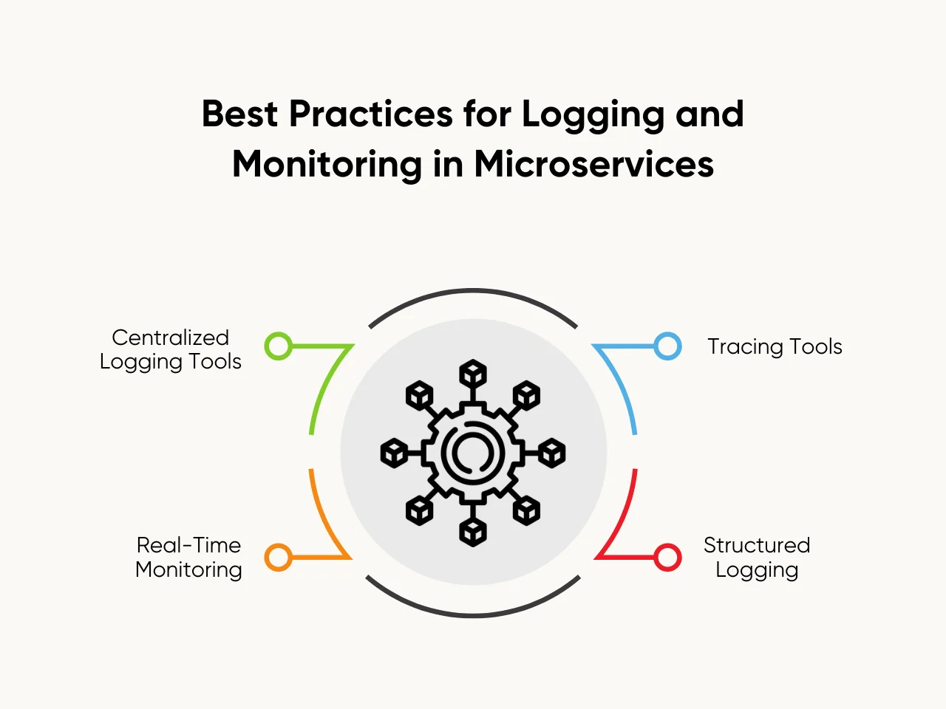

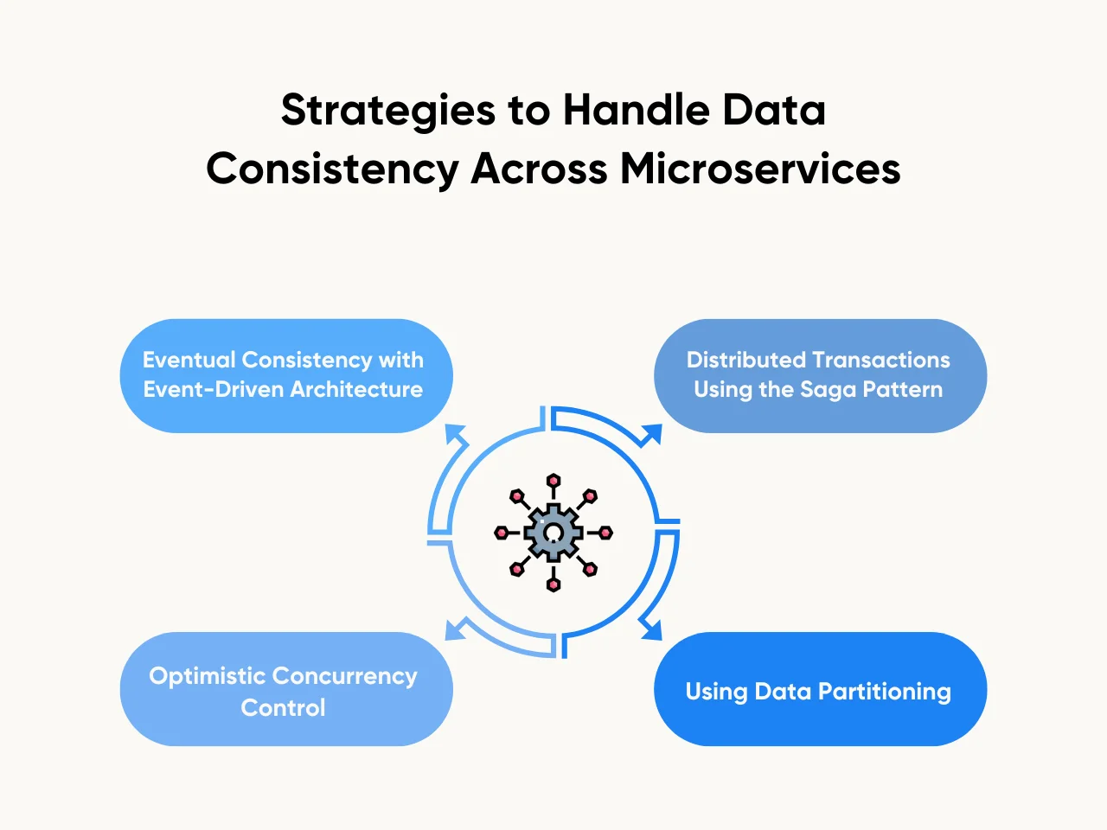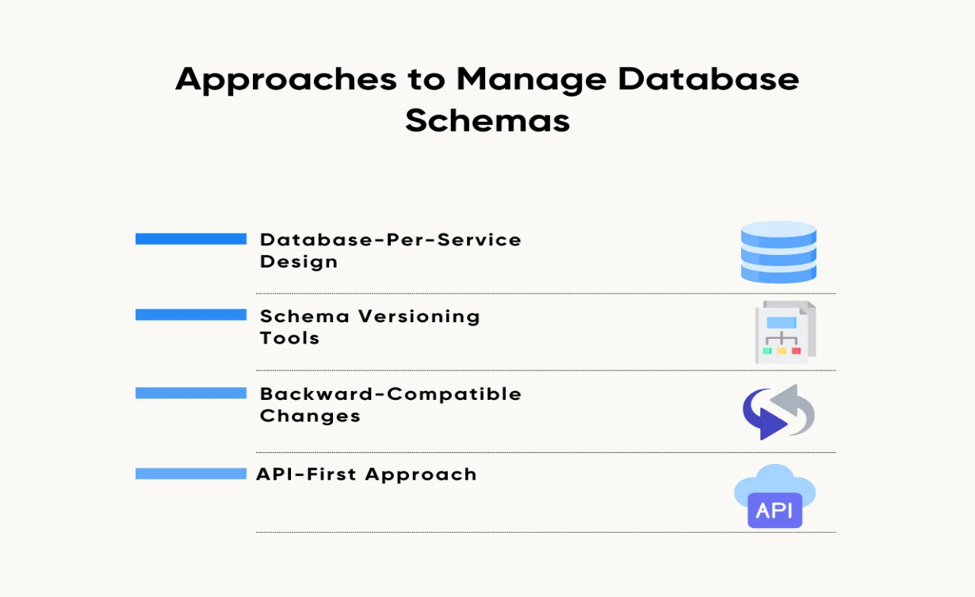

- Database-Per-Service Design: Each microservice has its database, ensuring full autonomy. This approach reduces dependencies and allows teams to update schemas without affecting other services.
- Schema Versioning Tools: Liquibase enables version-controlled updates, ensuring every change is logged and reversible. These tools streamline migrations across different environments.
- Backward-Compatible Changes: Introducing fields or columns that do not break existing queries ensures service communication continues during updates. This approach ensures seamless updates with no downtime.
- API-First Approach: Microservices expose APIs that abstract schema changes from external consumers, ensuring external systems remain unaffected.
Managing schema changes for a service relying on a shared customer database requires careful planning. Teams often prioritize approaches that reduce dependencies between services while ensuring data consistency. Microservices interview questions often focus on these techniques to test a candidate's understanding of schema management in distributed systems.
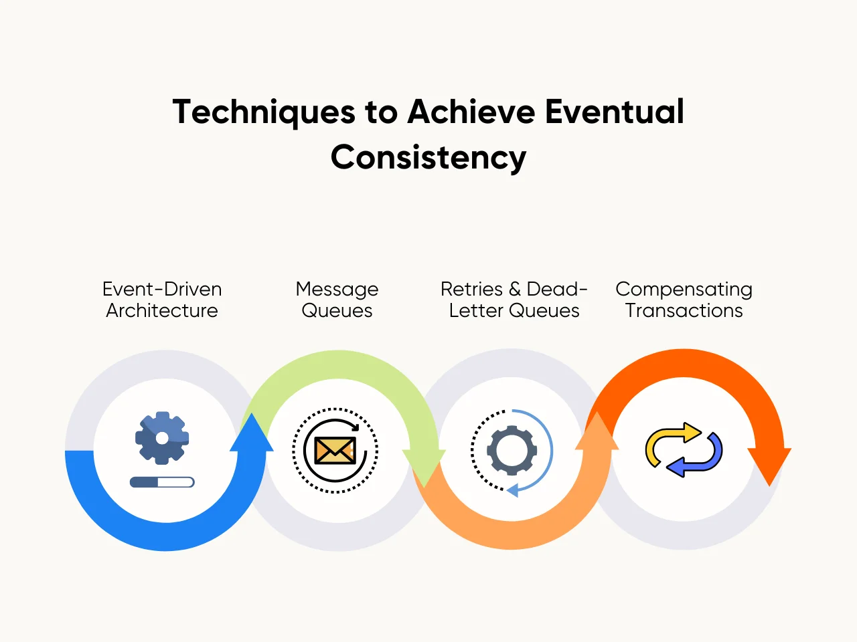

- Event-Driven Architecture: Services publish events when state changes occur, enabling other services to update their states asynchronously.
- Message Queues: Tools like RabbitMQ or Kafka help decouple services, ensuring reliable message delivery and consistency.
- Retries and Dead-Letter Queues: Retrying failed operations ensures delivery, while dead-letter queues handle undelivered messages for further inspection.
- Compensating Transactions: When an error occurs, compensatory actions reverse the effects of previous steps to restore a consistent state.

